Ashwini



Capstone Project

Sales Forecasting – Notes 1

Contents

INTRODUCTION 3

Problem Statement 3

Need of the study/project 3

Understanding business/social opportunity 3

Data Report 3

Understanding how data was collected in terms of time, frequency and methodology 3

Visual inspection of data (rows, columns, descriptive details) and attributes 3

Exploratory data analysis 4

Univariate analysis (distribution and spread for every continuous attribute, distribution of data in categories for categorical ones) 4

City, Product, Date Range: 4

Box plot for Sales and product Box plot for Sales and city 5

Sales and Product Sales and City 6

City and product and sales 6

Date and product and sales 7

Coolers 7

Dry Iron 8

Food Processor 8

Gas Stove 8

Induction Cookers 9

Mixers 9

Oven Toaster grill 10

SECF 10

Steam Iron 10

Water Heaters 11

Date and city and sales 11

Ahmedabad 11

Bangalore 11

Chennai 12

Cochin 12

Delhi 12

Hyderabad 13

Kolkata 13

Mumbai 13

Patna 14

Pune 14

Date and city and sales and product 14

Cooler vs Cities vs Date 14

Dry Iron vs Cities vs Date 15

Food Processor vs Cities vs Date 15

Gas Stove vs Cities vs Date 15

Induction Cookers vs Cities vs Date 16

Mixers vs Cities vs Date 16

Oven toaster grill vs Cities vs Date 17

SECF vs Cities vs Date 17

Steam Iron vs Cities vs Date 17

Water Heaters vs Cities Vs Date 18

Missing Data and duplicates 18

Outlier treatment 18

Business Insights 18

# INTRODUCTION

## Problem Statement

Sales play a pivotal role in a company to gain profit. Each product in an appliance company might sell based on different aspects on that particular product. We can apply different marketing strategies to sell the products. So this projects involves applying Time series forecasting techniques to predict the sales for the upcoming years to curb and increase the production of products and gain profit.

## Need of the study/project

Sales is the most important aspect of a company. All companies ought to find effective business strategies to persuade customers to buy their products. However, sales might go down and up based on different aspects such as weather condition, customer’s usage and product performance. We need to identify product sales behaviour over a period of time and forecast the sales in the upcoming years to help the production of products, drop the product from the list or increase the production according to the season. Time series forecasting algorithm have a pretty good performance on purpose to predict the sales of the different products in different cities for a period of time

## Understanding business/social opportunity

Understanding the Business/Social Opportunity Forecasting the sales with accuracy helps the appliance company to have better clarity on existing and prospective customers. They can accordingly increase or diminish their production of different products. If the company produces excess product, but the sales of that particular product is down, then that particular product remain in the store indefinitely. As a repercussion, company will incur production cost loss and product sale loss. So forecasting sales will help the company in maintaining good repute and increased revenues.

# Data Report

## Understanding how data was collected in terms of time, frequency and methodology

The dataset indicates different home appliance products from different states of India. There are 10 products available with demographic variables – Sales of products from different cities and sales of each product from April 2014 till March 2018 on the 1st of every month for each city.

## Visual inspection of data (rows, columns, descriptive details) and attributes

The dataset contains 4800 observations spread across 4 variables. Product, City are categorical variable. Date and Sales are continuous variables. Each product has 480 records varying in different months of the year.

# Exploratory data analysis

## Univariate analysis (distribution and spread for every continuous attribute, distribution of data in categories for categorical ones)

Note : date has been changed to datetimeformat and Month- Date- Year format for further analysis

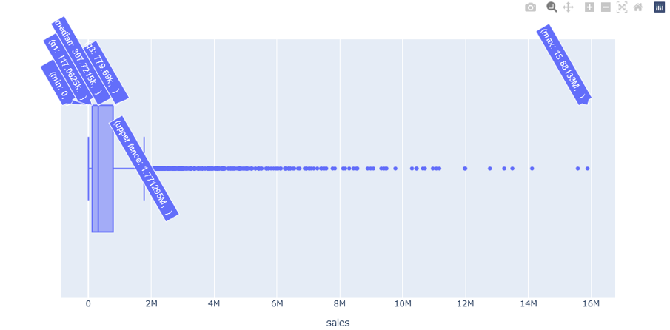

Sales variable is continuous and have outliers in the Box plot fig shown above.

Min is 0 and max outlier is 15.88M.

Outlier is not treated for sales variables because forecasting the sales data will get compromised for products during the analysis and accurate results cannot be achieved.

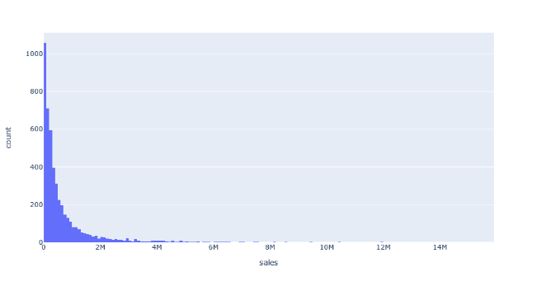

Sales is right skewed and ranging from 0 to 14 M

75% data is between 0 and 2.5 M

## City, Product, Date Range:

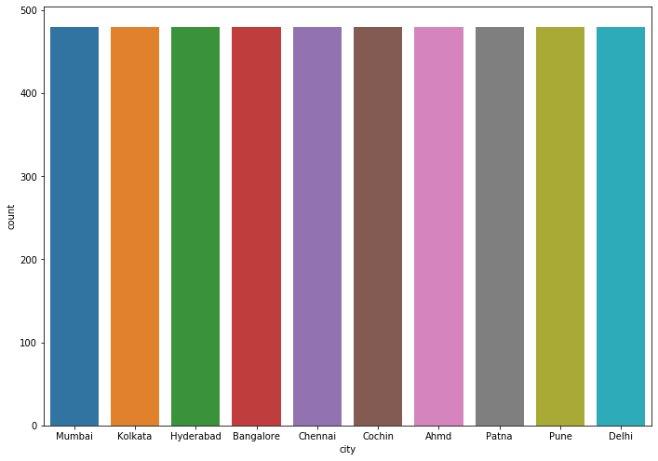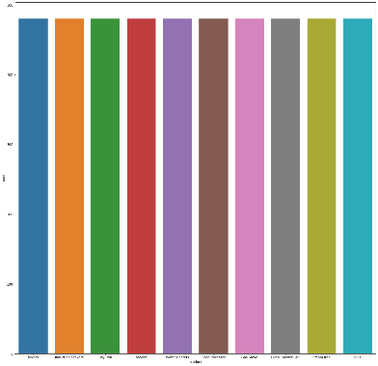

City and product are equally distributed each having 480 rows individually

There are total of 10 different cities in geographical area to be explored

There are 10 different product in different cities, for which sales has to be forecasted

Date range is from April 2014 to March 2018 containing 1st date of every month.

## Box plot for Sales and product Box plot for Sales and city

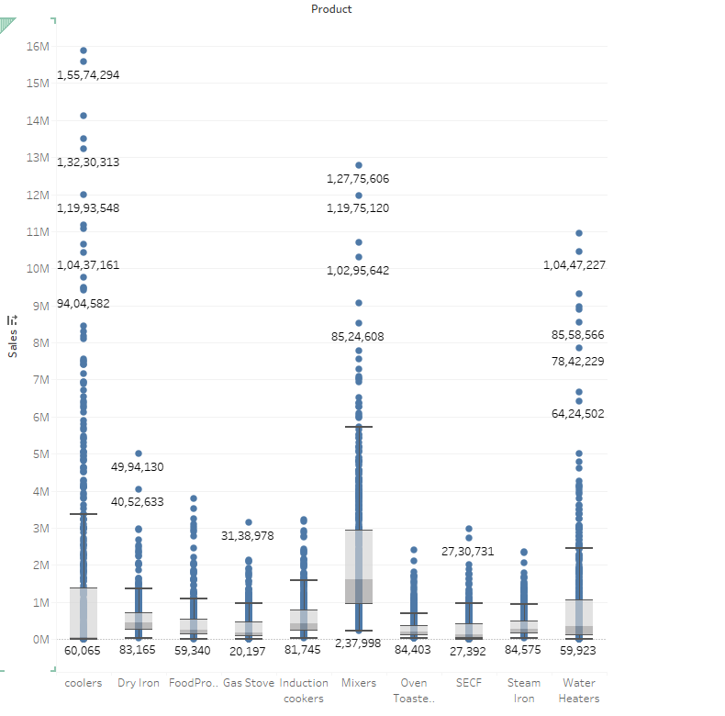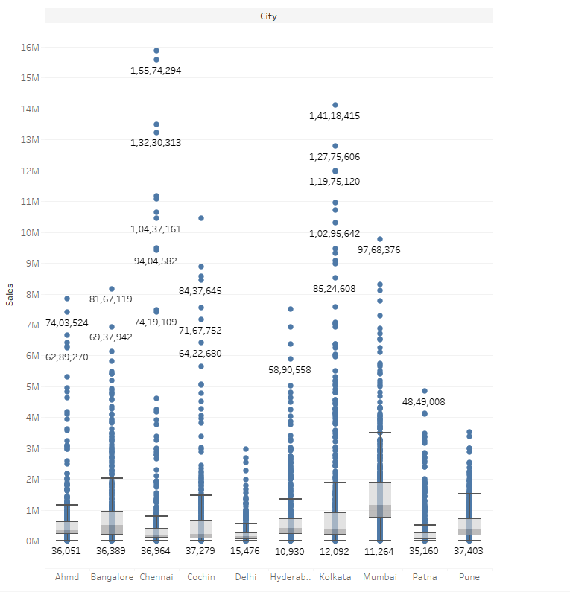

All products have outliers

Coolers , Mixers and Water heaters have the highest outliers

All Cities have outliers

Kolkata, Chennai and cochin have the highest outliers

We are not treating outliers because time series forecasting requires continuous data and treating outliers would not give us best outcomes.

## Sales and Product Sales and City

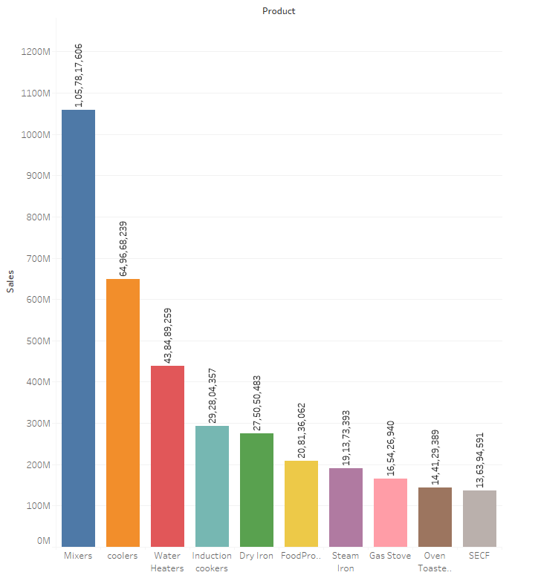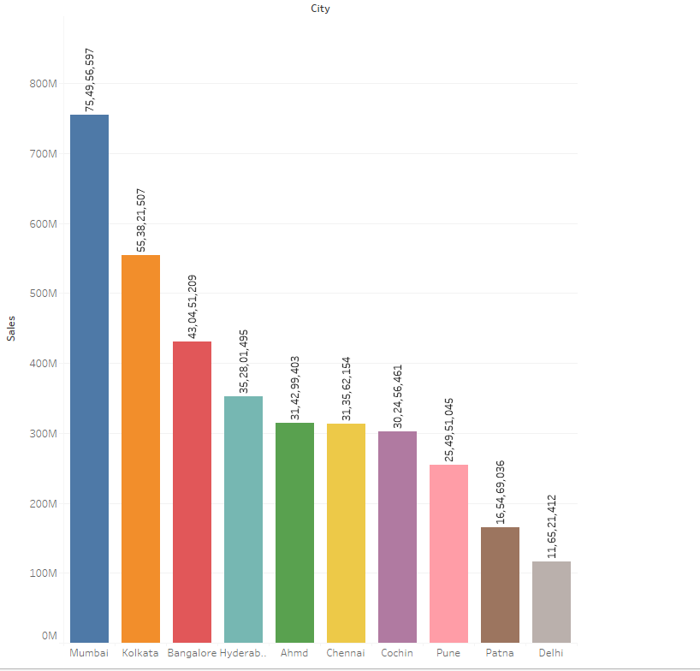

Sales of mixers is the highest and SECF are the lowest

Similarly, Mumbai has highest sales of products and Delhi recorded lowest among others.

Based on above fig, we can concentrate more sales of mixers and adequate numbers of products in stock in Mumbai

For product SECF, production can be minimised based on sales pattern over the years and products sold in Delhi have to be revisited to understand, why sales drops and production of products and sales business strategies to be carried on.

## City and product and sales

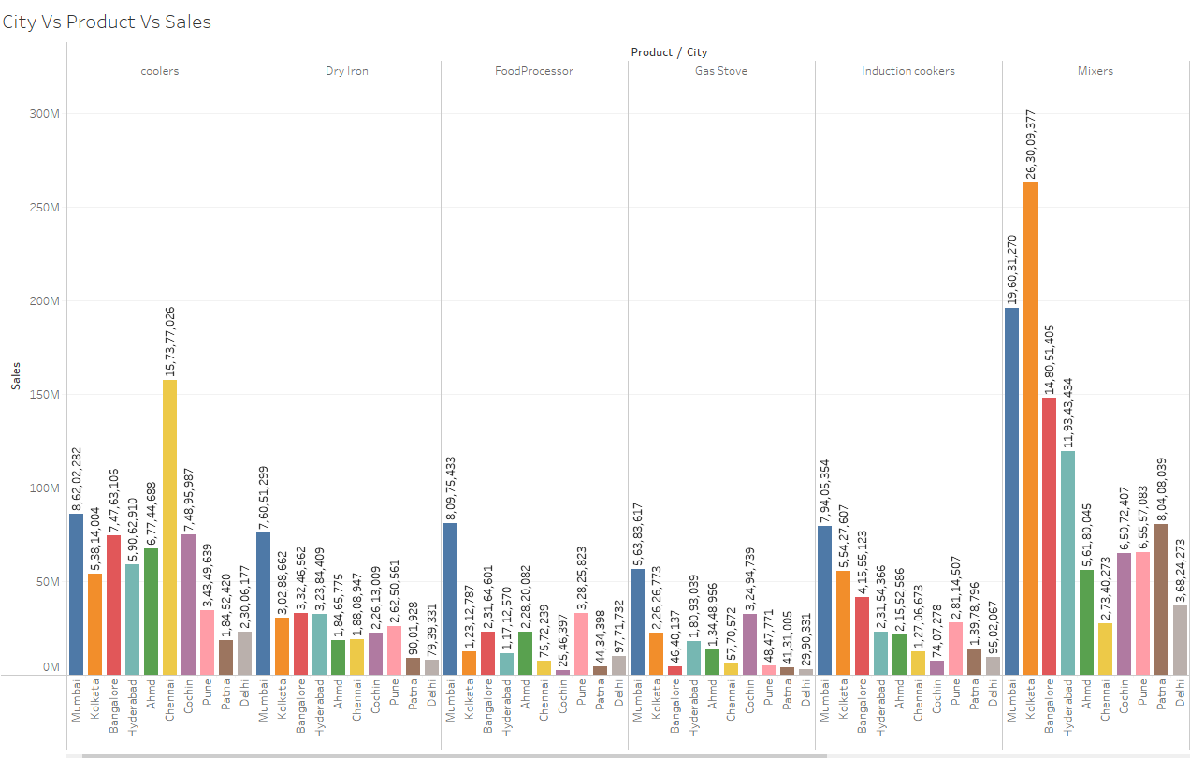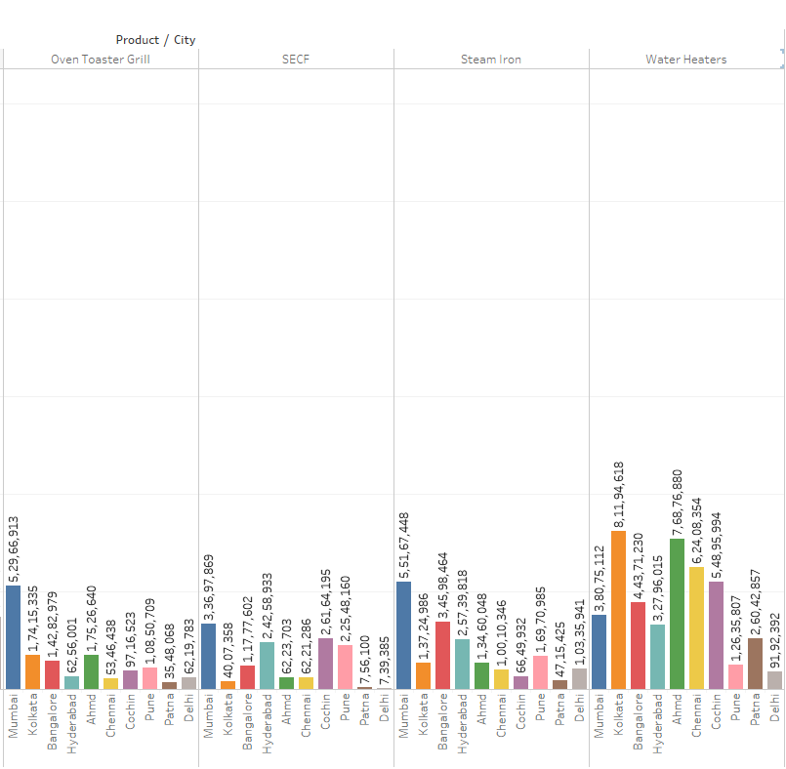

Above fig gives a detailed understanding for sales across different cities and products

**Coolers**: Chennai has the highest sales and Patna has the lowest sales.

Production of coolers should be more in Chennai and business strategies should be explored for very low sales in Patna.

**Dry Iron :** Sales of dry iron is highest in Mumbai and lowest in Delhi

Production of dry iron should be more in Mumbai and business strategies should be explored for very low sales in Delhi.

**Food processor :** Sales are high in Mumbai and Lowest in Cochin

Production of Food processor should be more in Mumbai and business strategies should be explored for very low sales in Cochin.

**Gas Stove :** Sales are high in Mumbai and Lowest in Delhi

Production of Gas Stove should be more in Mumbai and business strategies should be explored for very low sales in Delhi.

**Induction Cookers** : Sales are high in Mumbai and Lowest in Cochin

Production of Induction Cookers should be more in Mumbai and business strategies should be explored for very low sales in Cochin.

**Mixers :** Sales are high in Kolkata and Lowest in Chennai

Production of Mixers should be more in Kolkata and business strategies should be explored for very low sales in Chennai.

**Oven Toaster grill :** Sales are high in Mumbai and Lowest in Patna

Production of Oven toaster grill should be more in Mumbai and business strategies should be explored for very low sales in Patna.

**SECF :** Sales are high in Mumbai and Lowest in Delhi

Production of SECF should be more in Mumbai and business strategies should be explored for very low sales in Delhi.

**Steam Iron :** Sales are high in Mumbai and Lowest in Patna

Production of Steam Iron should be more in Mumbai and business strategies should be explored for very low sales in Patna.

**Water Heater :** Sales are high in Kolkata and Lowest in Delhi

Production of Water Heater should be more in Kolkata and business strategies should be explored for very low sales in Delhi.

## Date and product and sales

### Coolers

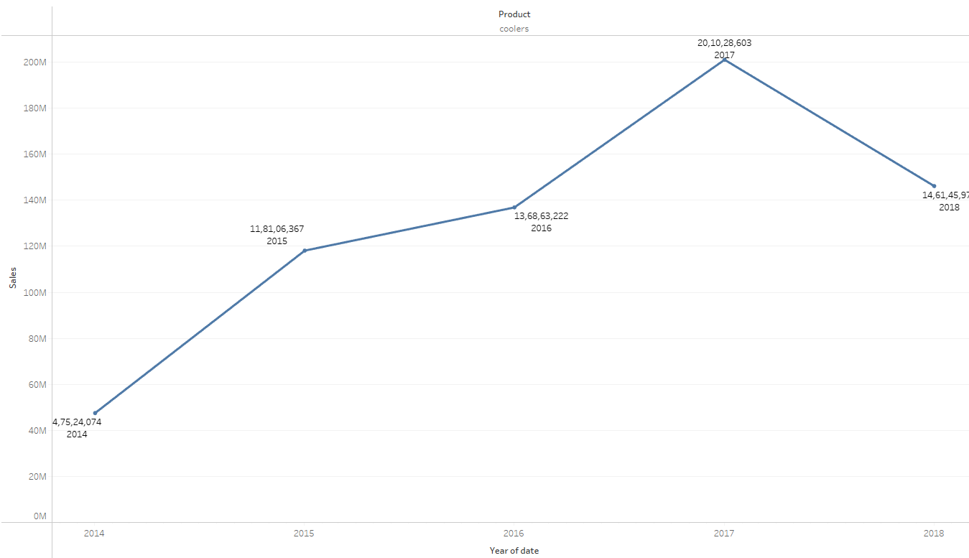 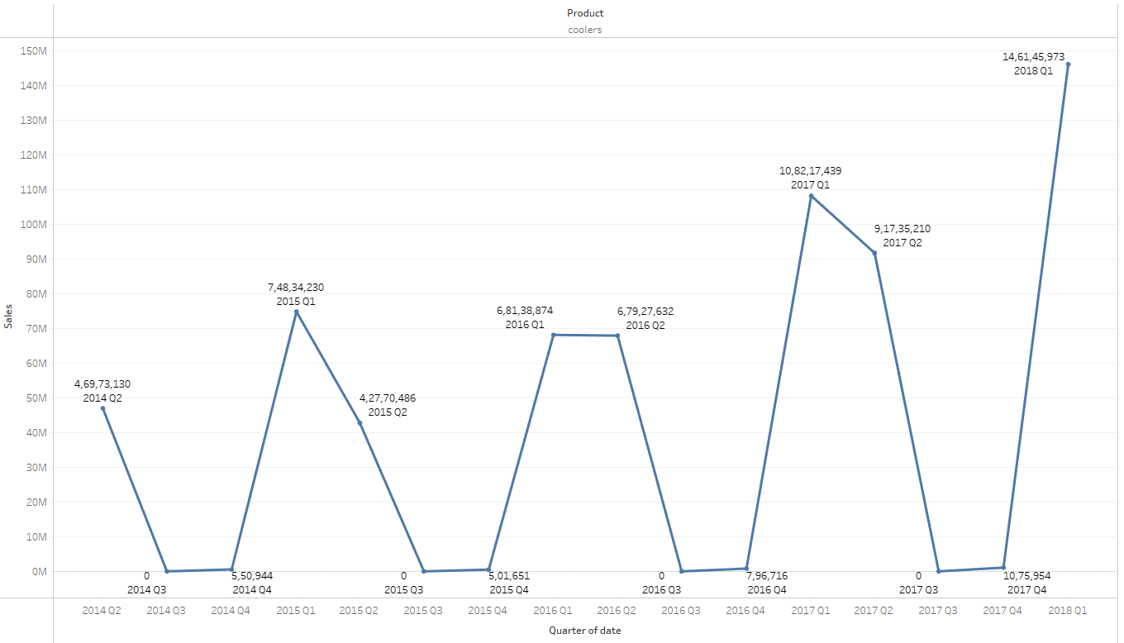 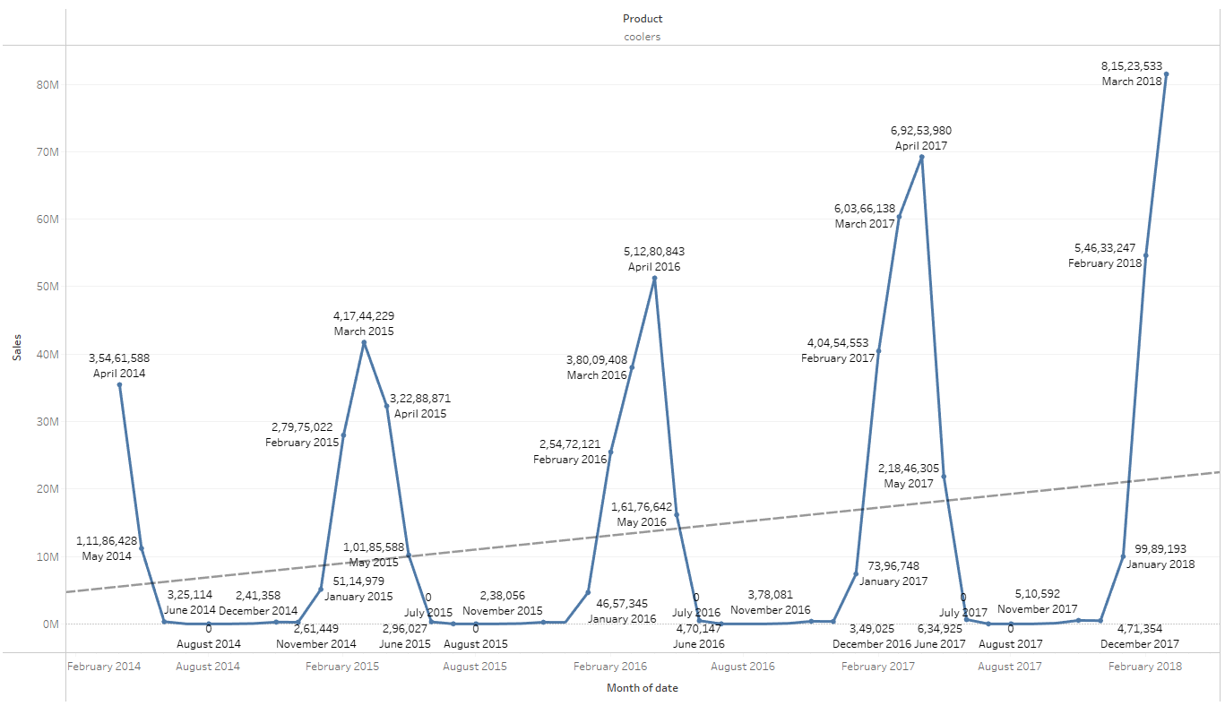

Yearly – Product sales started of low in 2014, goes pick in 2017 and takes a light dip in 2018 of Q1 due to limited data in 2018

Quarterly – 2014 Q2 sales took of well and we could see a pattern of dip during Q3 and Q4

Monthly – sales dips during the month of June to December through all years from 2014 to 2017. However, sales increases over the years.

### Dry Iron

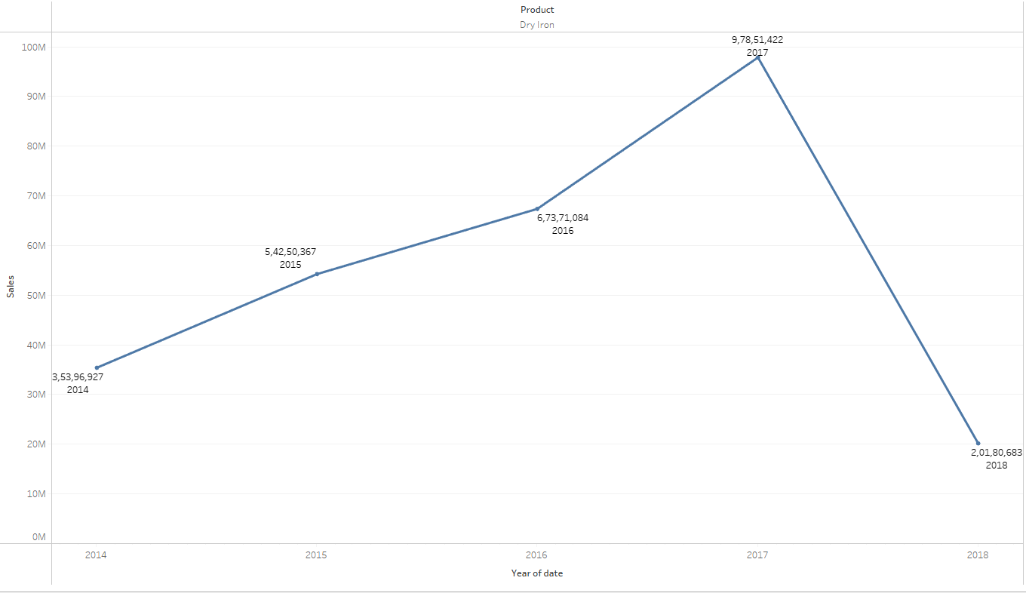 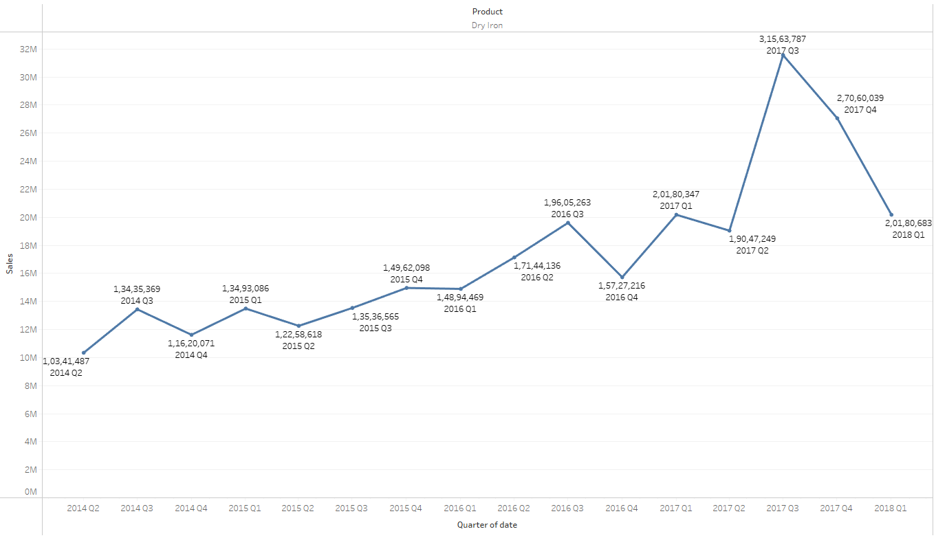 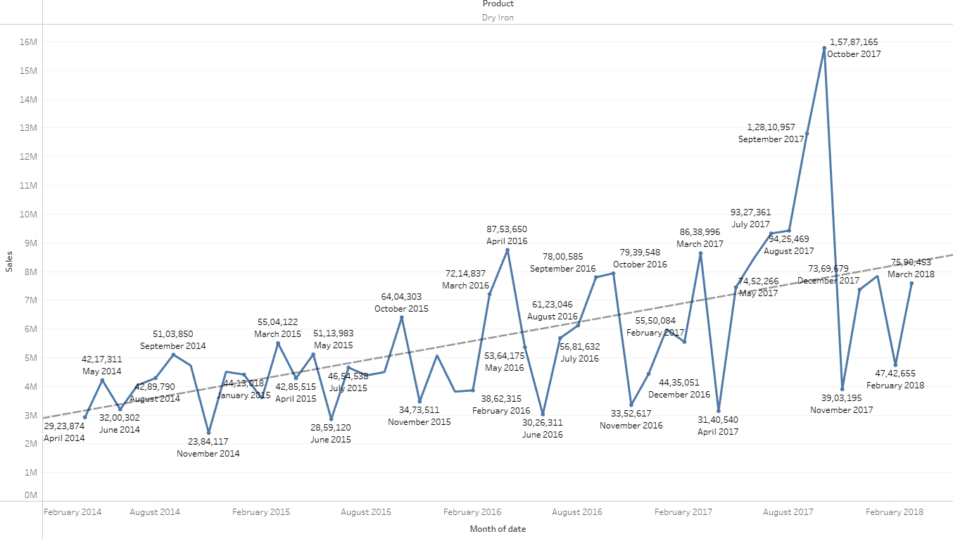

Yearly – Started of low in 2014 , sales was at pick at 2017 and took a dip at 2018 of Q1 due to limited data in 2018

Quarterly – Started of low in Q2 2014, Q3 of all years takes a rise in sales

Monthly – November takes a dip in sales in all years. Trend line shows an increasing sales over the years.

### Food Processor

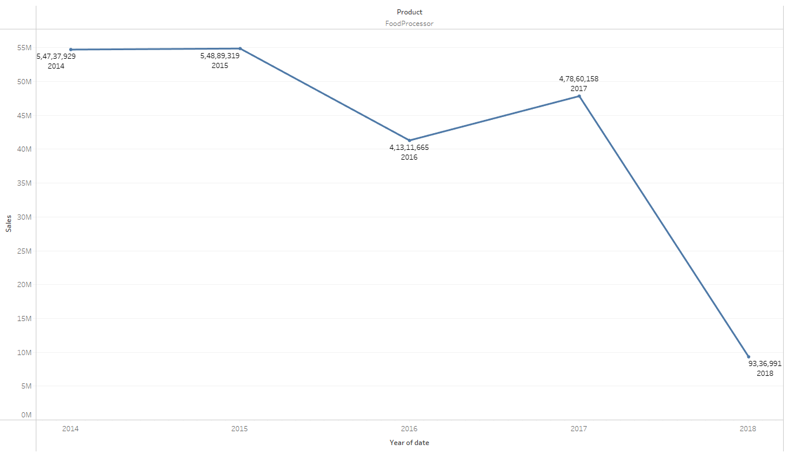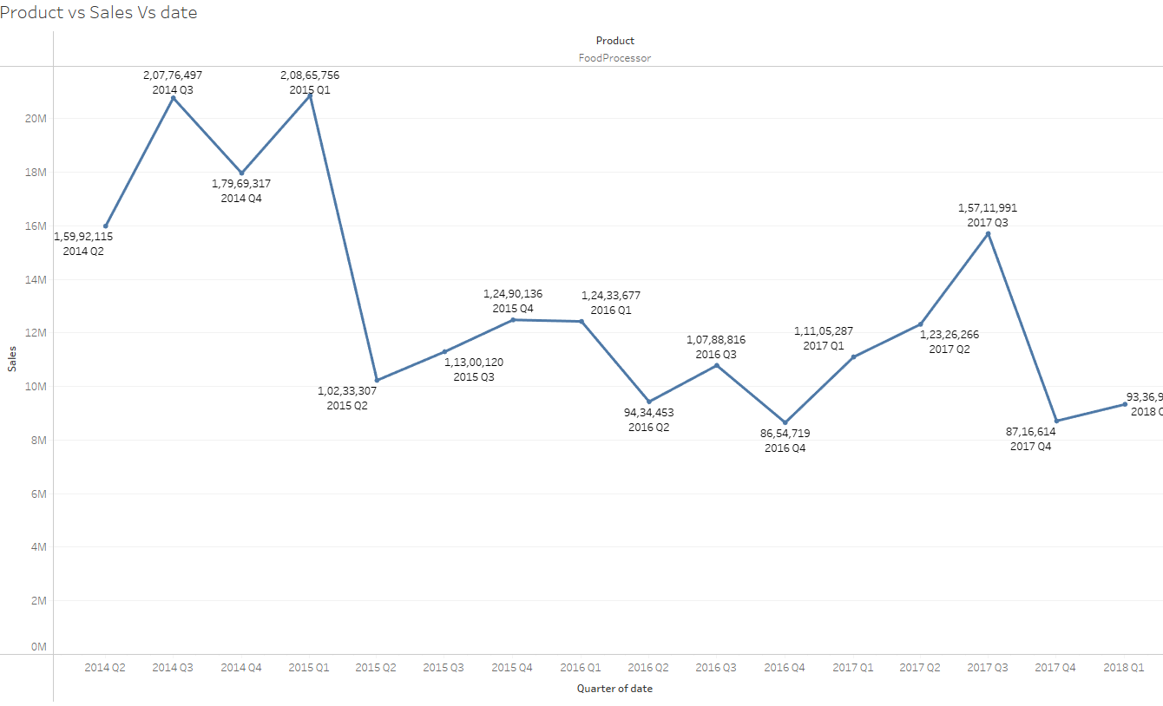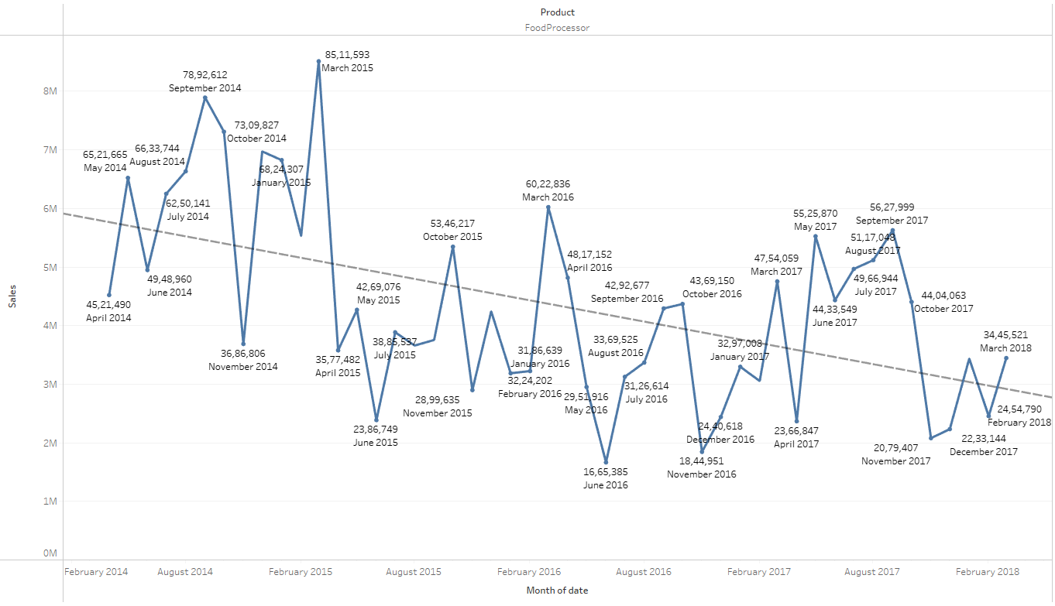

Yearly – Steady sales in 2017 dip in 2016. Rise in 2017 and heavy low sales in 2018 of Q1 due to limited data in 2018

Quarterly – There is a low in sales in Q2 for 2014,2015,2016. Q4 for 2017 and 2018

Monthly- No particular trend for monthly data based on products. Trend line shows there is dip in sales as the years pass by

### Gas Stove

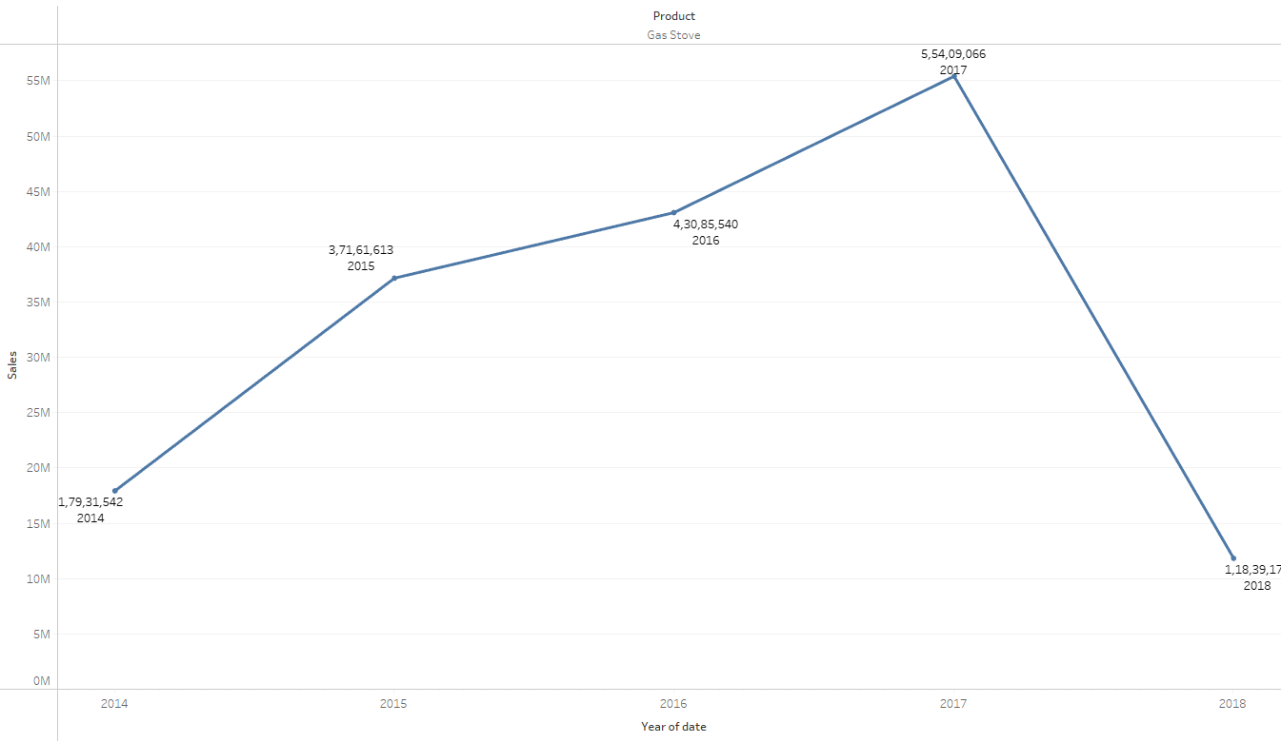 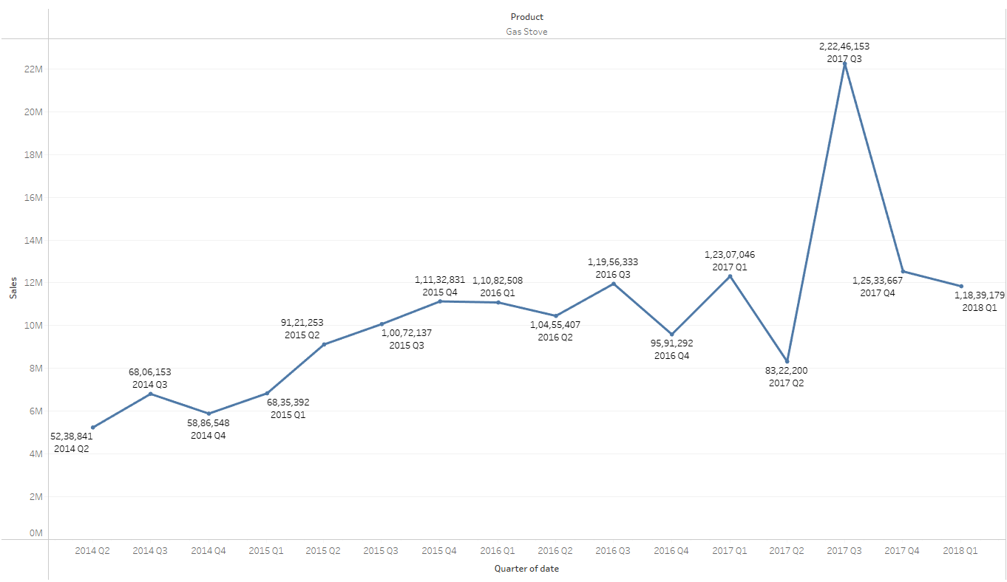 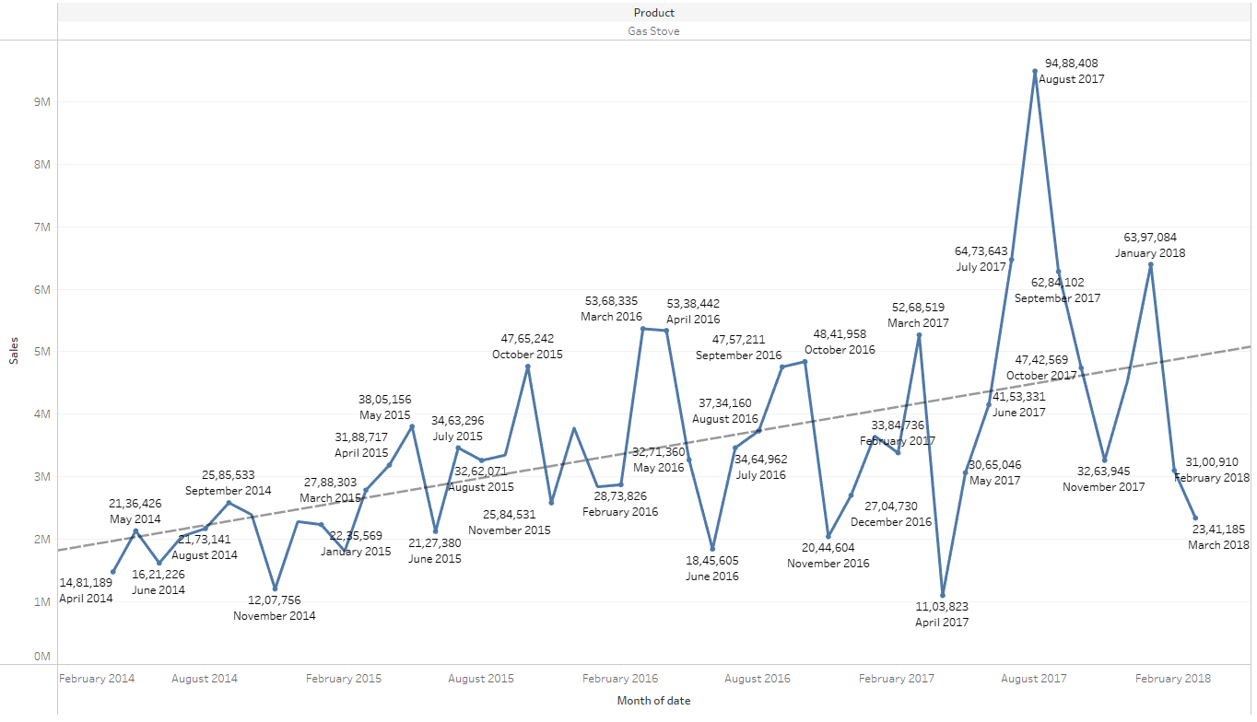

Yearly – Starts low at 2014,takes a peak gradually from 2015 to 2017 and falls in 2018, since we have limited data in Q1 in 2018

Quarterly – Sales is at peak in Q3 in 2017, no particular trend

Monthly – Sales is at peak at august 2017. Trend line shows an increase in sales gradually over the years

### Induction Cookers

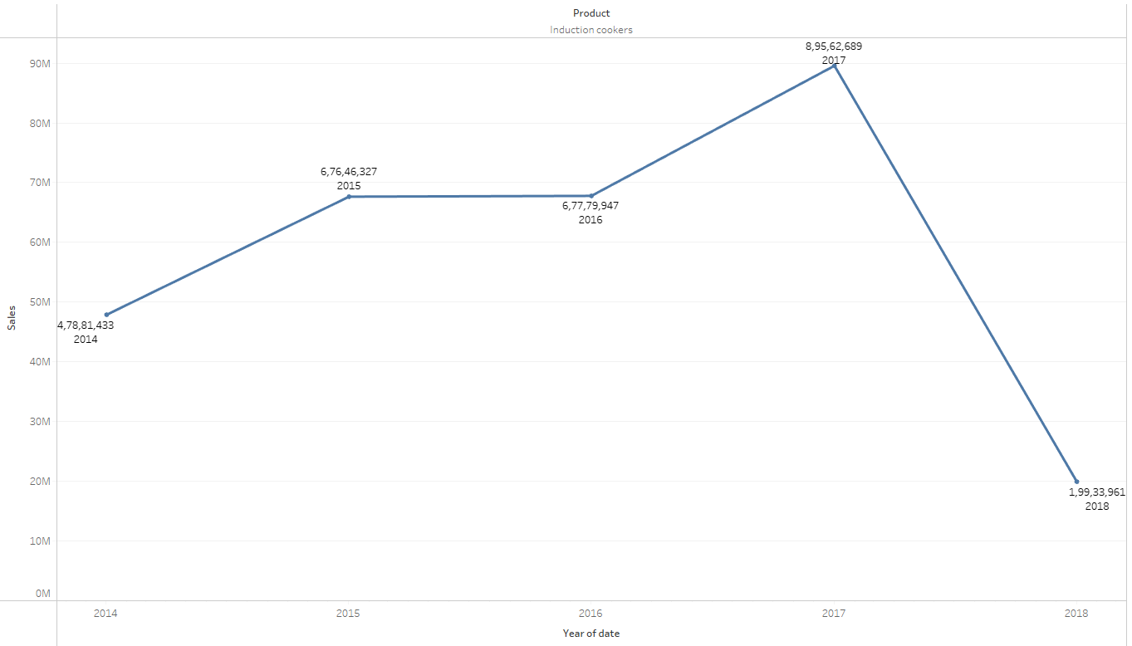 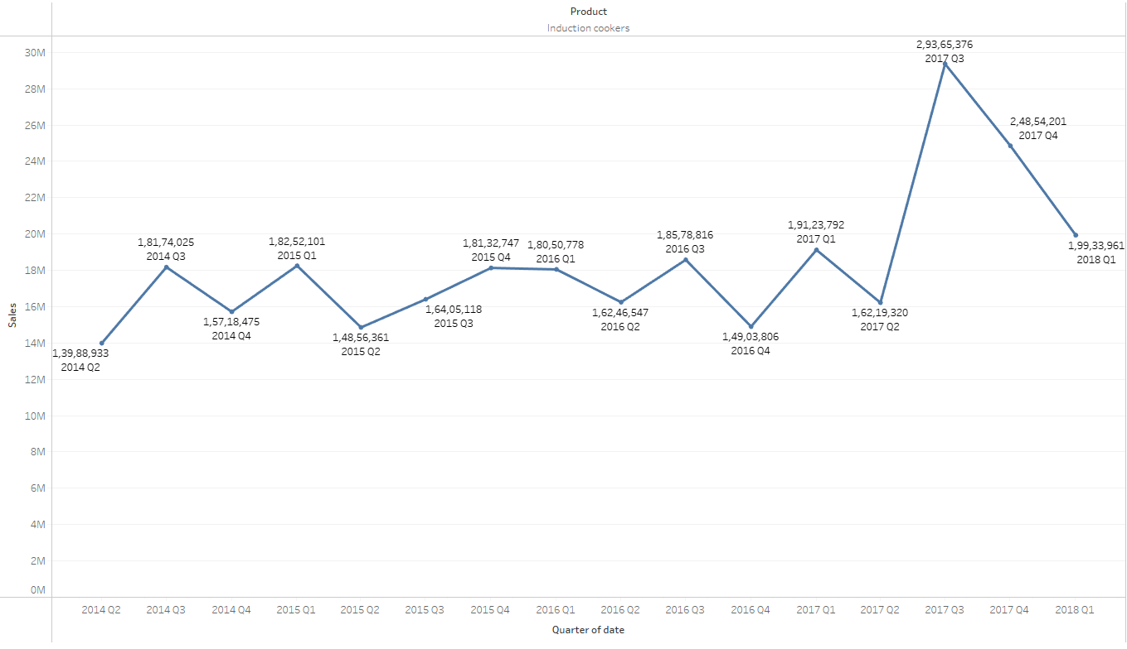 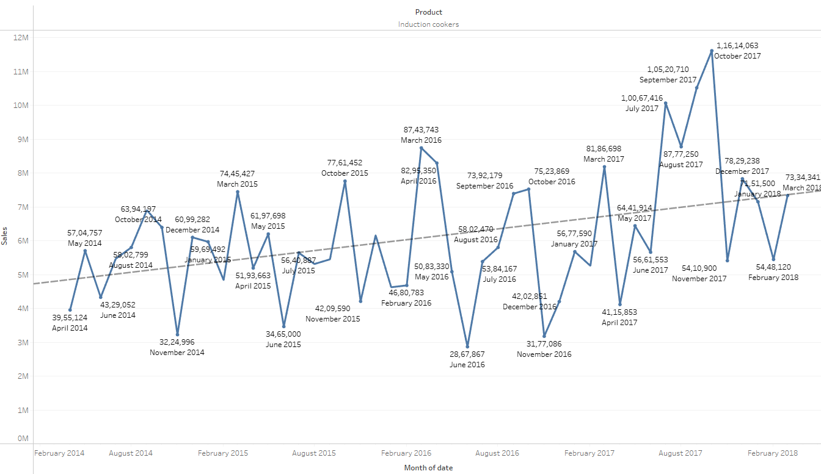

Yearly – Steady increase from 2014 and sales goes to peak at 2017 and takes a dip at 2018 because of limited data of Q1 in 2014 and 2016

Quarterly – There is a dip in Q2 in all years

Yearly- November has a consistent fall in sales in all years. There is increasing trend of sales in product

### Mixers

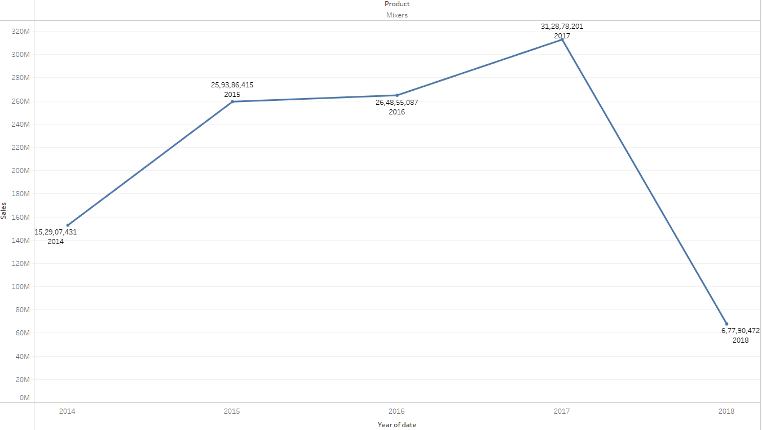 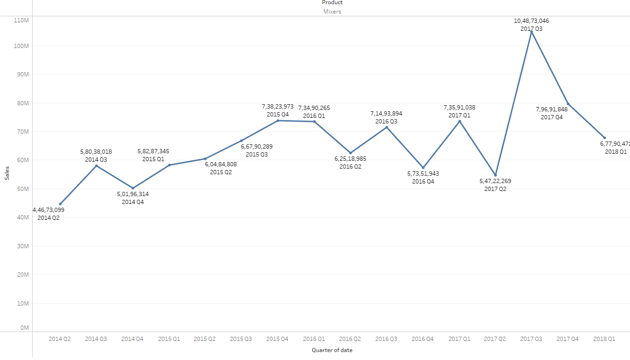 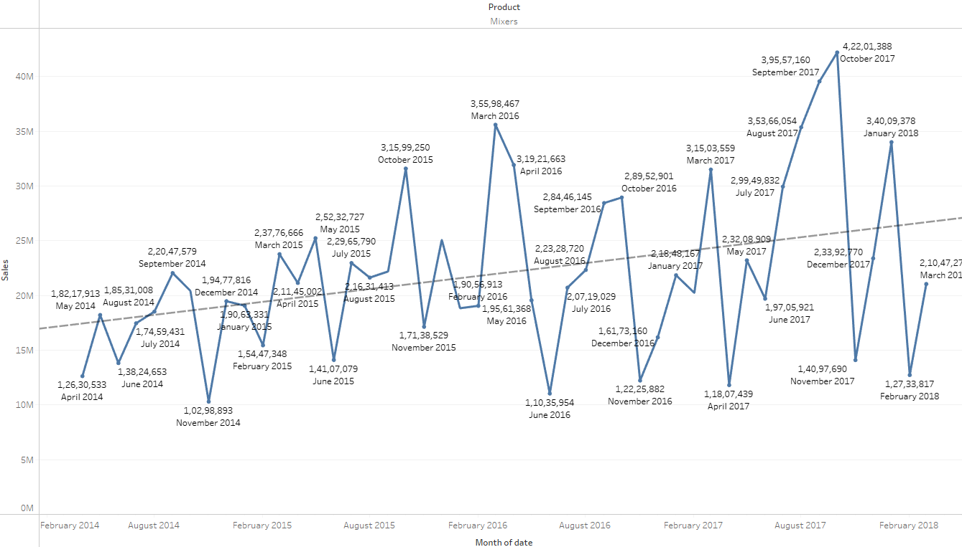

Yearly – Steady increase from 2014 and sales goes to peak at 2017 and takes a dip at 2018 because of limited data of Q1 in 2014

Quarterly – Sales is at peak in Q3 in 2017

Yearly - November has a consistent fall in sales in all years. There is increasing trend of sales in product

### Oven Toaster grill

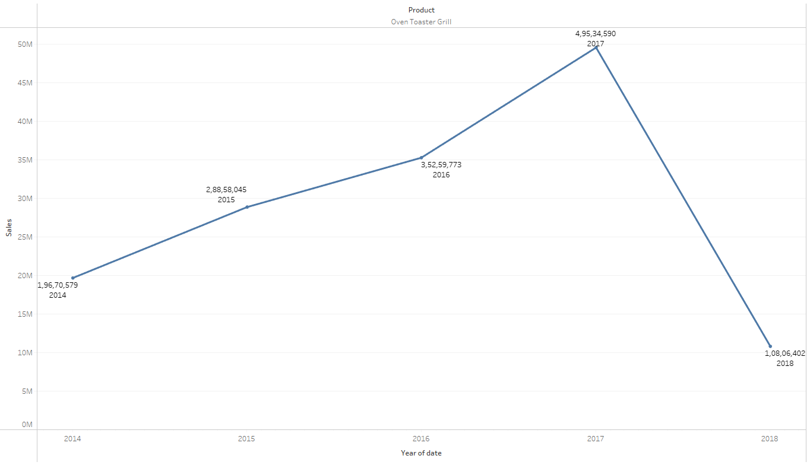 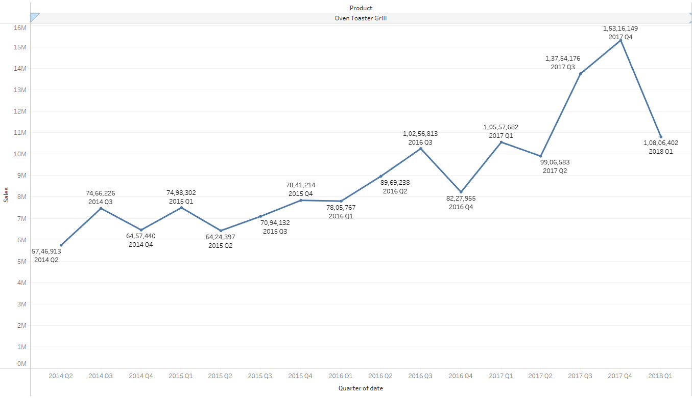 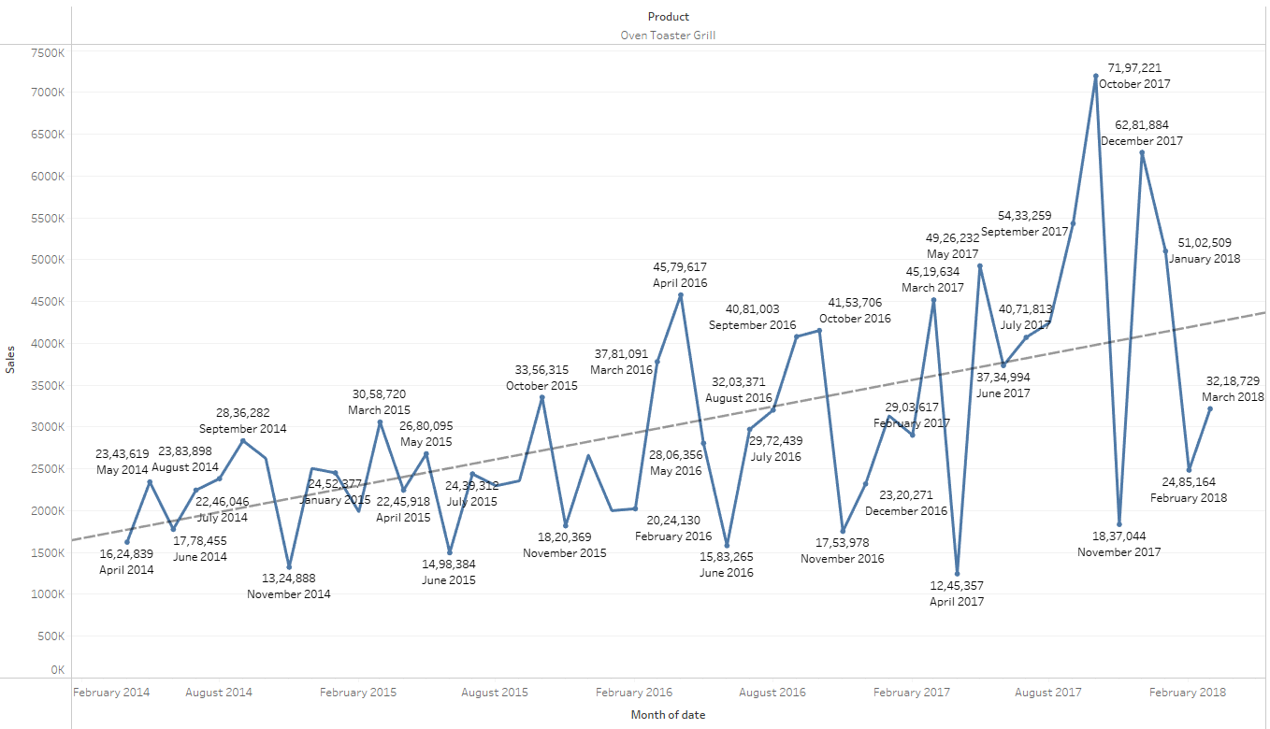

Yearly – Steady increase from 2014 and sales goes to peak at 2017 and takes a dip at 2018 because of limited data of Q1 in 2014

Quarterly – Sales is at peak in Q4 in 2017

Monthly - November has a consistent fall in sales in all years. There is increasing trend of sales in product

### SECF

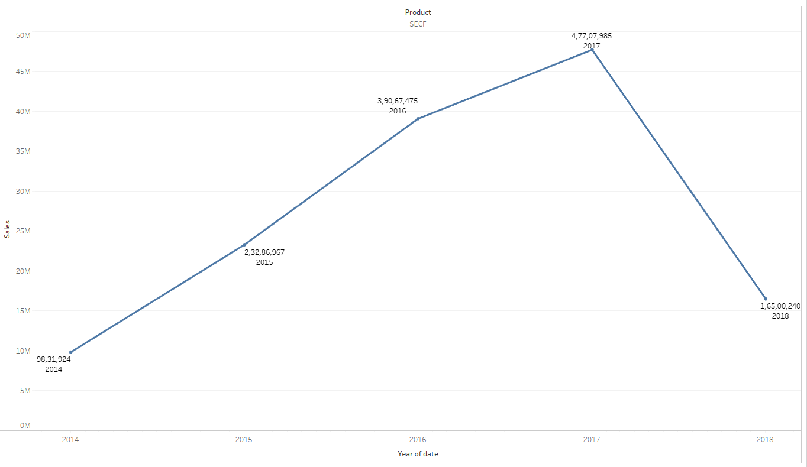 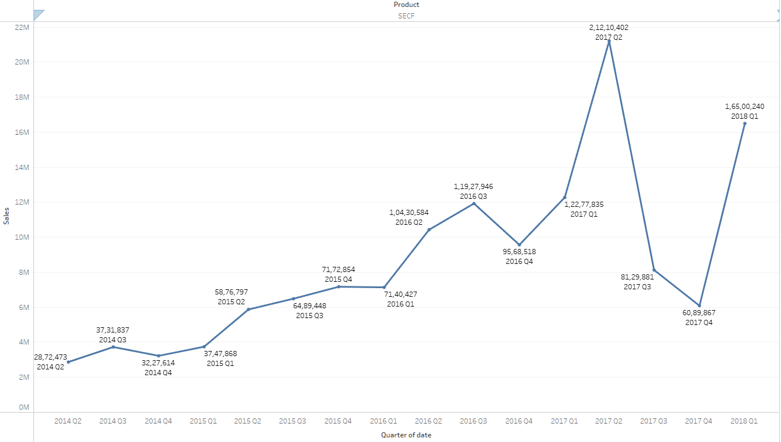 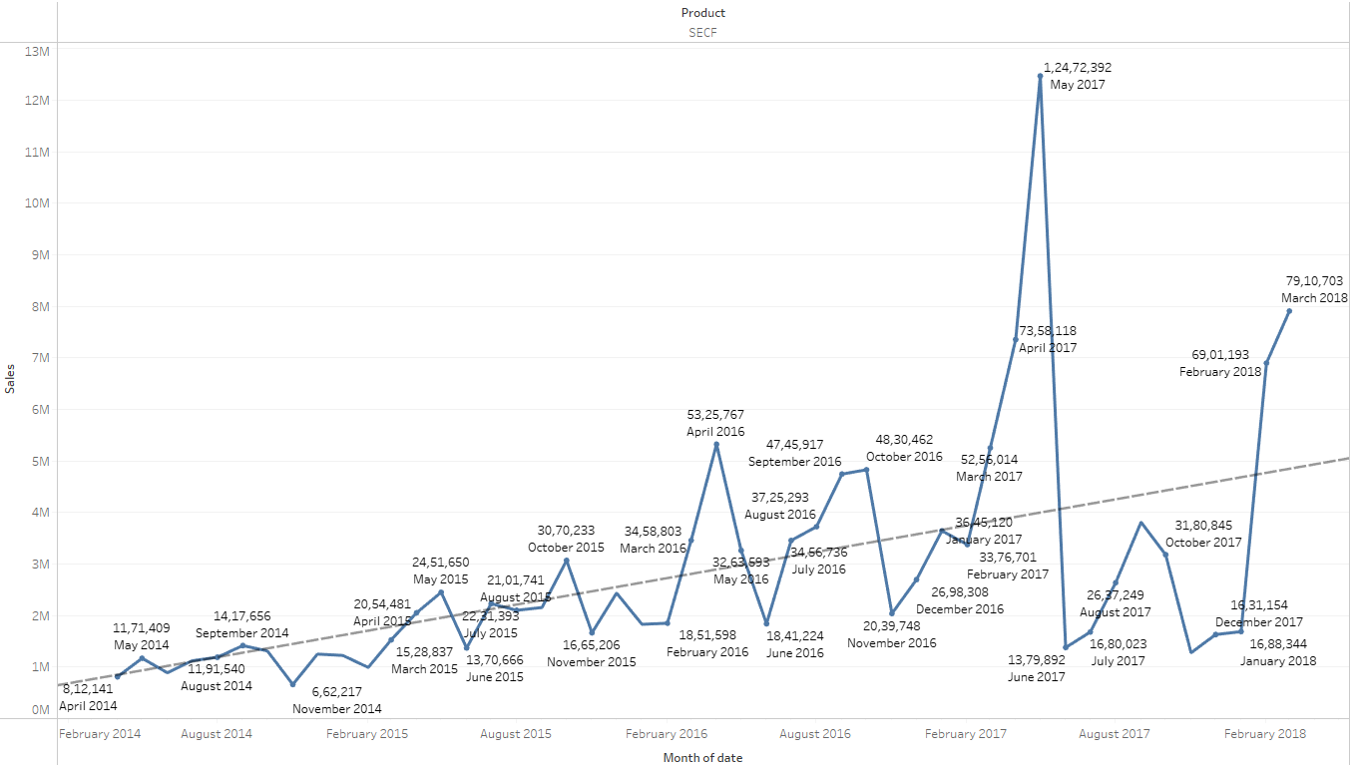

Yearly – Steady increase from 2014 and sales goes to peak at 2017 and takes a dip at 2018 because of limited data of Q1 in 2014

Quarterly – Sales is at peak in Q2 in 2017. Unlike others there is an increase in sales 2018 Q1

Monthly - November has a consistent fall in sales in all years. There is increasing trend of sales in product

### Steam Iron

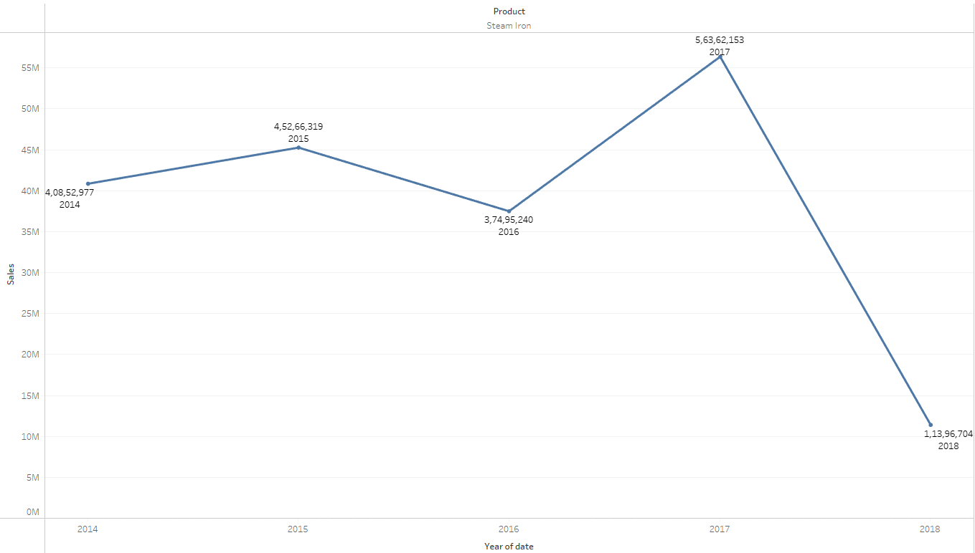 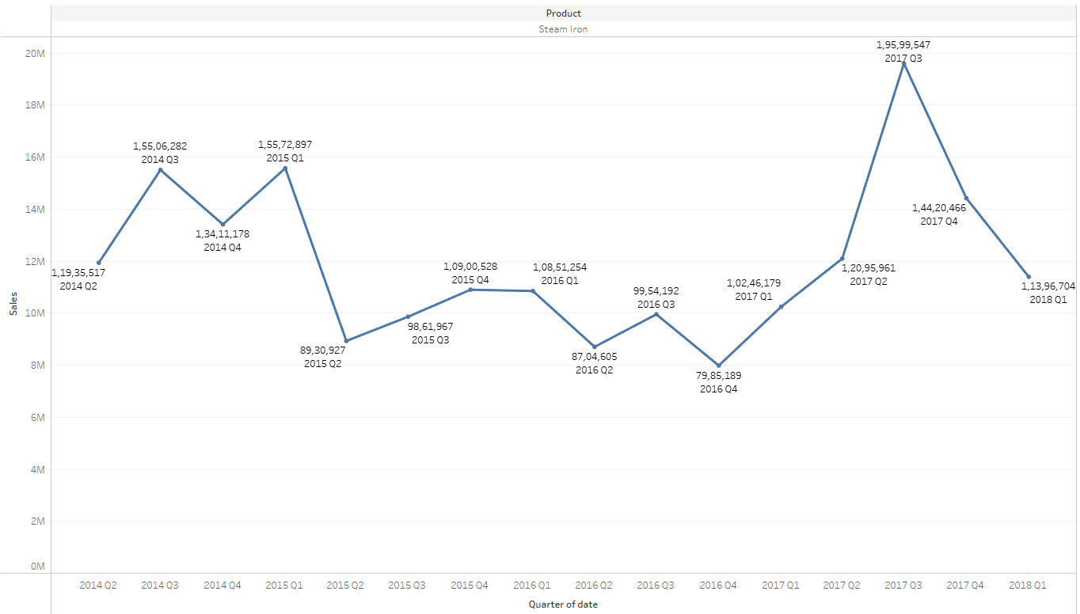 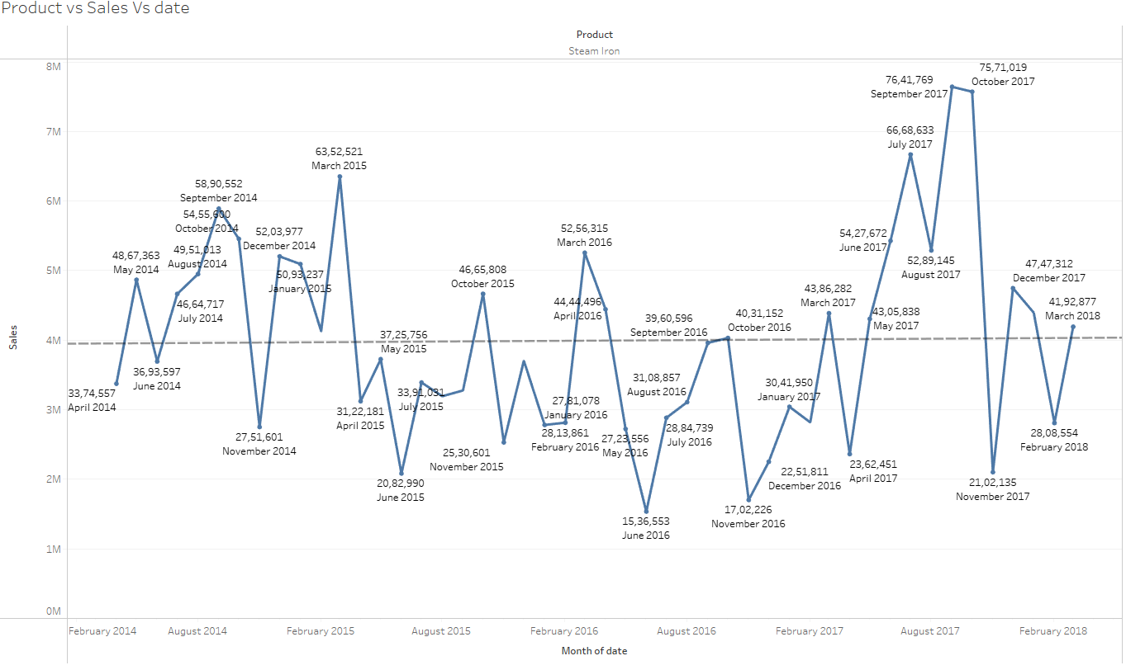

Yearly – Steady increase from 2014 to 2015. Decrease in sales in 2016 and sales is at peak in 2017 and again decrease in 2018

Quarterly – Sales is at peak during Q32017.

Monthly – No particular trend of sales and sales is at peak during September 2017

### Water Heaters

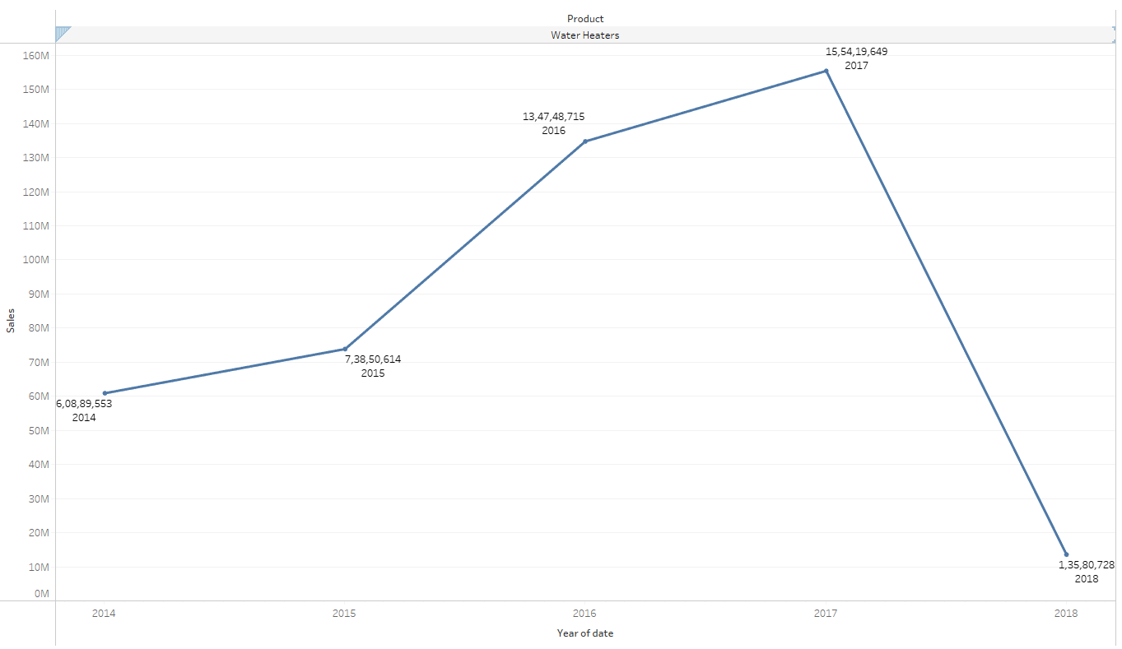 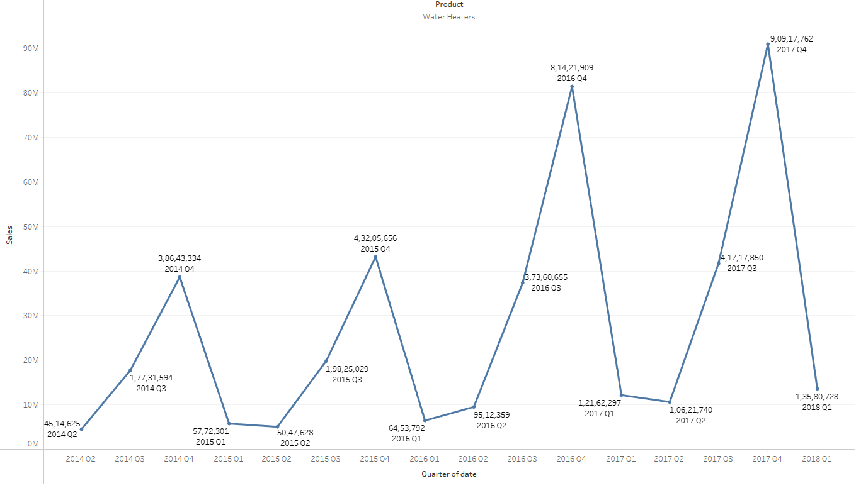 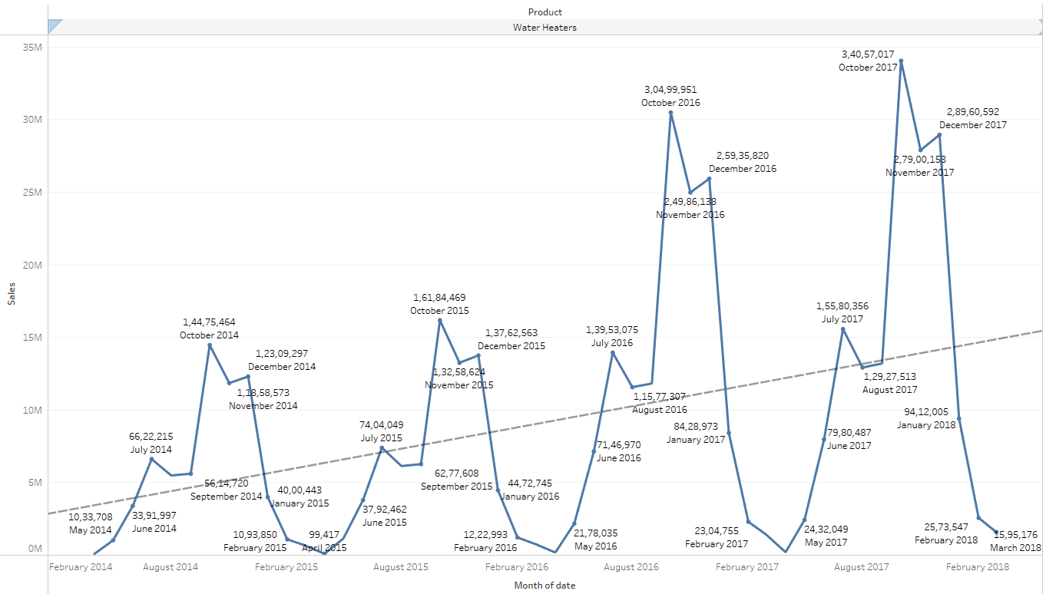

Yearly – Steady increase from 2014 and sales goes to peak at 2017 and takes a dip at 2018 because of limited data of Q1 in 2014

Quarterly – Sales drops during Q1 and Q2 in all years

Monthly – Steady increase in sales over the years

## Date and city and sales

### Ahmedabad

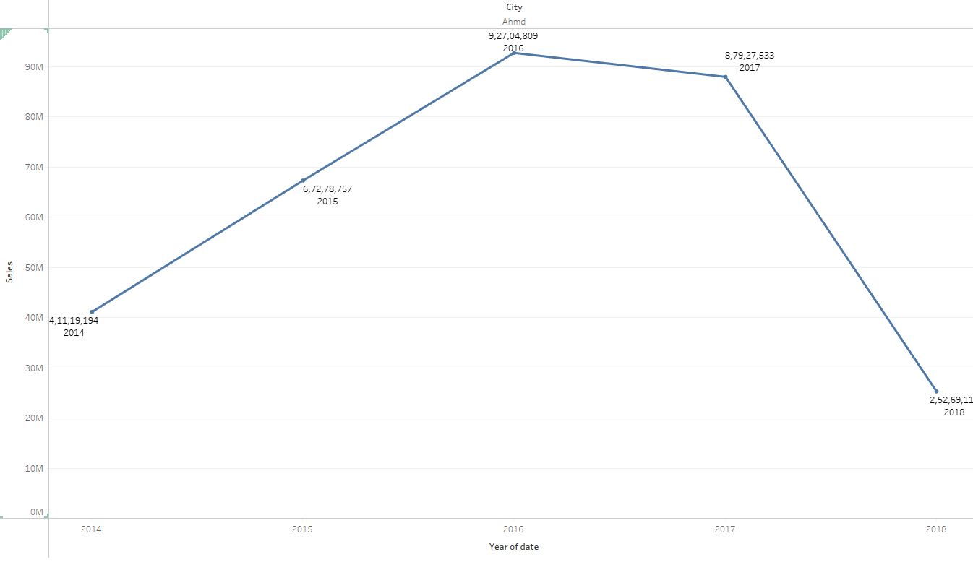 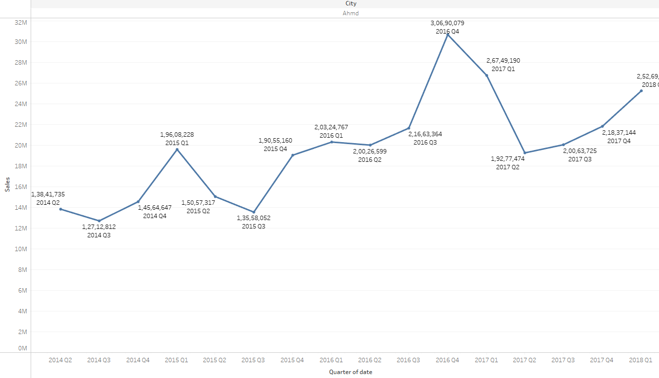 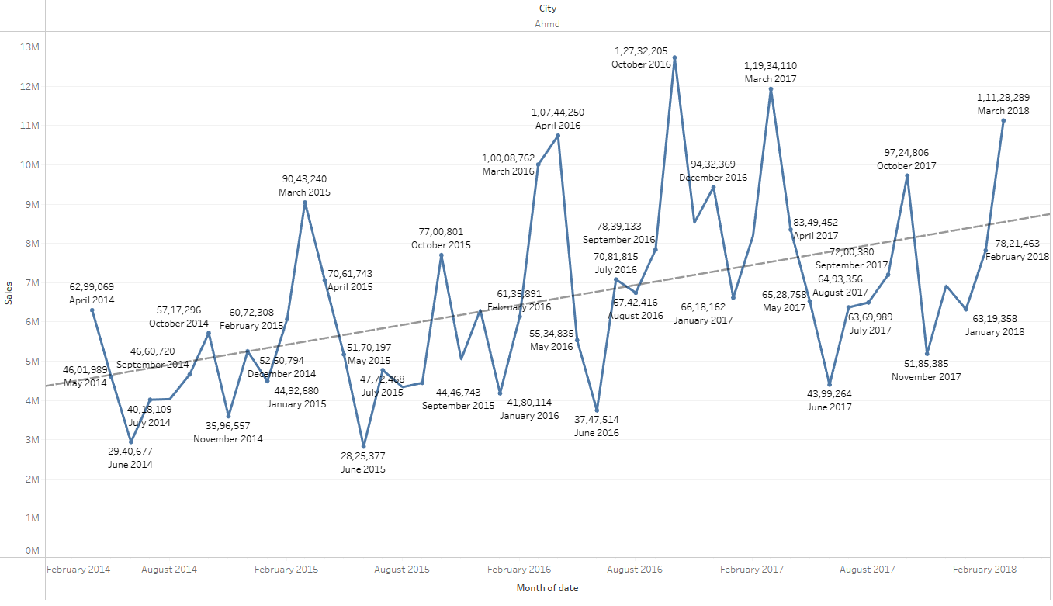

Yearly - Sales in 2014 started with 40M gradually increased till 2016, dip in 2017 and Q1 of 2018

Quarterly – Sales was at peak during Q4 of 2016

Monthly – There was a constant dip during June across all years and no particular pattern of rise or dip in sales. Trend line increases across the years.

### Bangalore

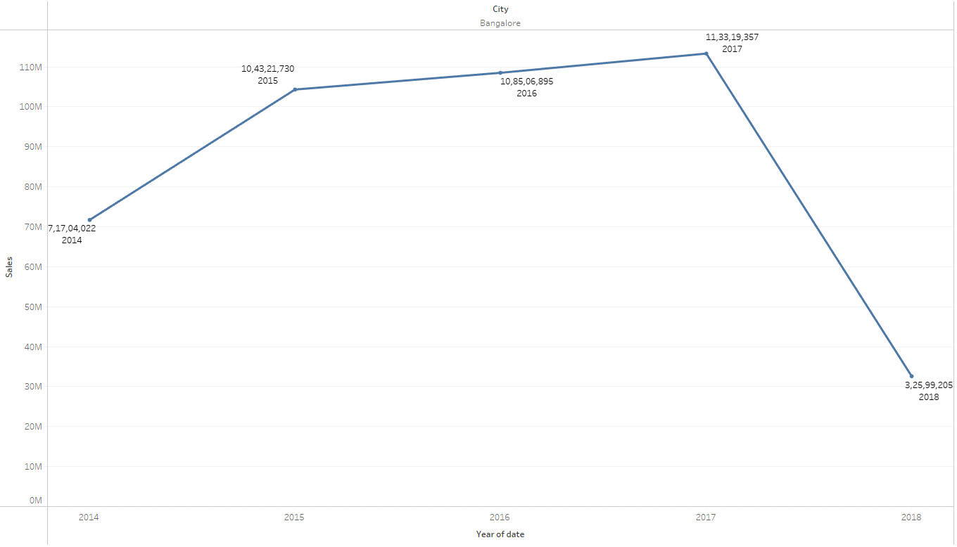 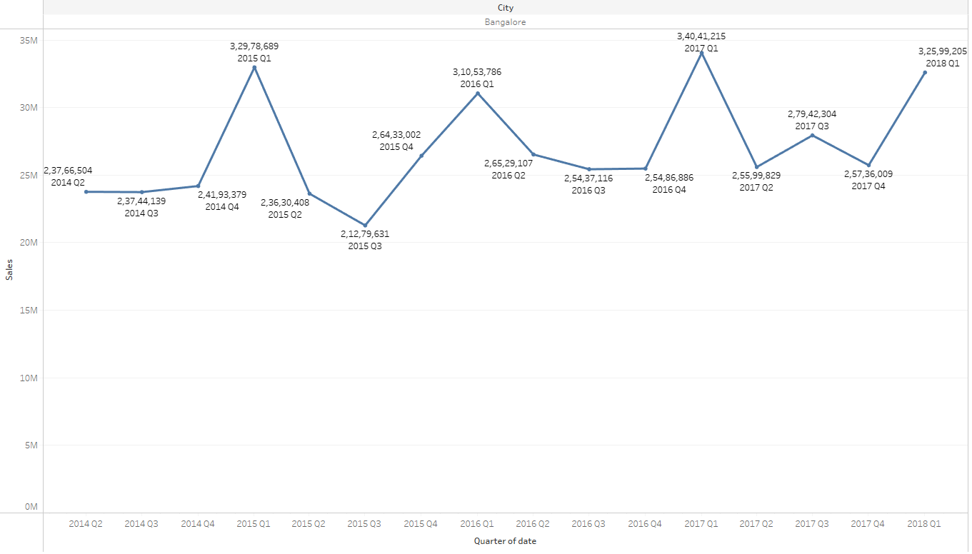 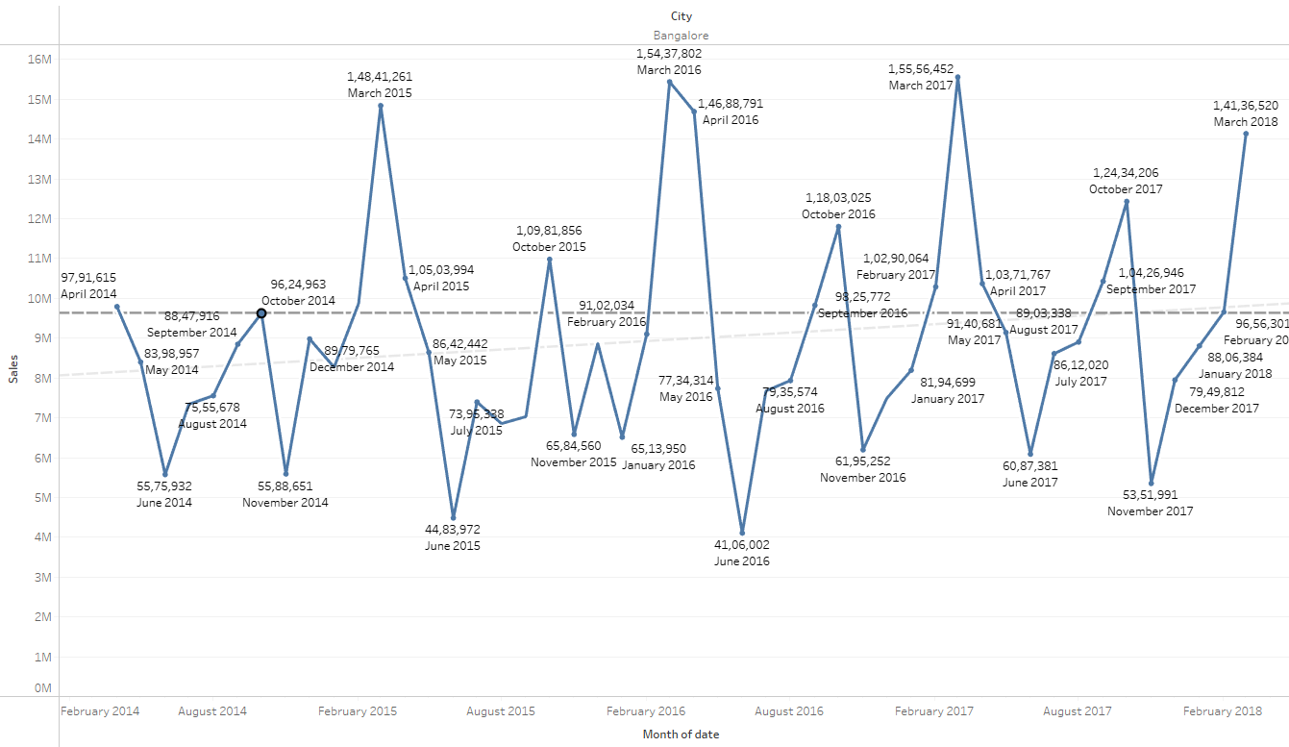

Yearly - Sales in 2014 started with 70M gradually increased till 2017, dip in Q1 of 2018

Quarterly – Sales was at peak during Q1 of 2017

Monthly – There was a constant dip during june and november across all years and no particular pattern of rise or dip in sales. Trend line increases acroos the years.

### Chennai

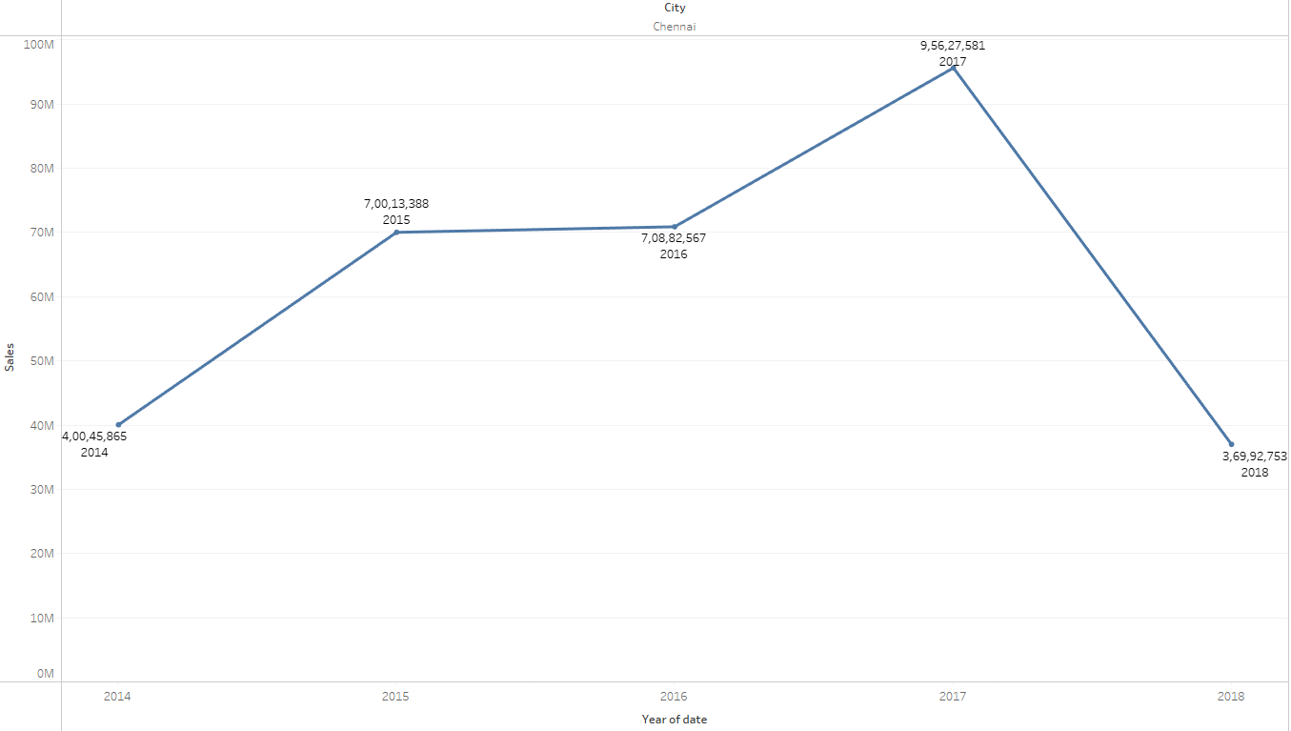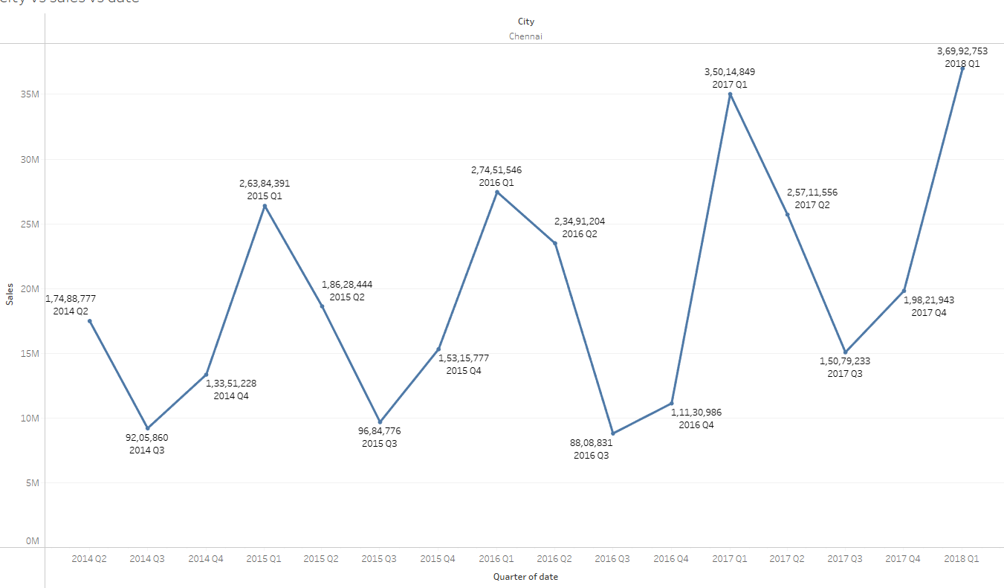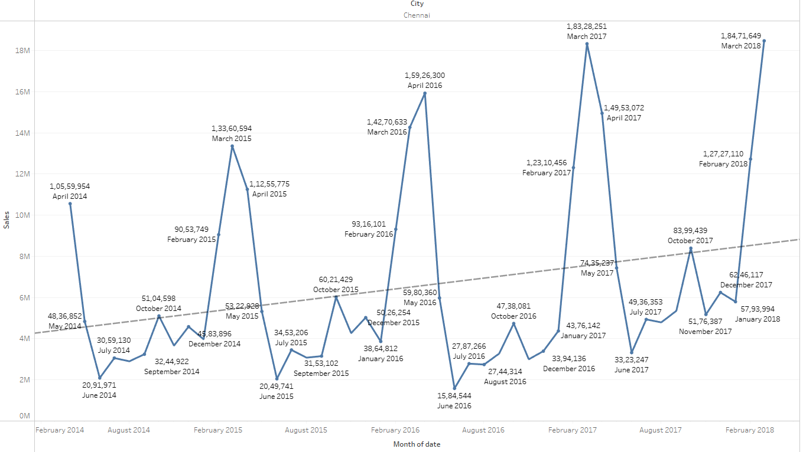

Yearly - Sales in 2014 started with 70M gradually increased till 2017, dip in Q1 of 2018

Quarterly – Sales was at peak during Q1 of 2018 and there is a pattern of dip in sales during Q3 across all years.

Monthly – There was a constant dip during June and increase in sales during April and march. Trend line increases across the years. There is pattern of sales increase and decrease

### Cochin

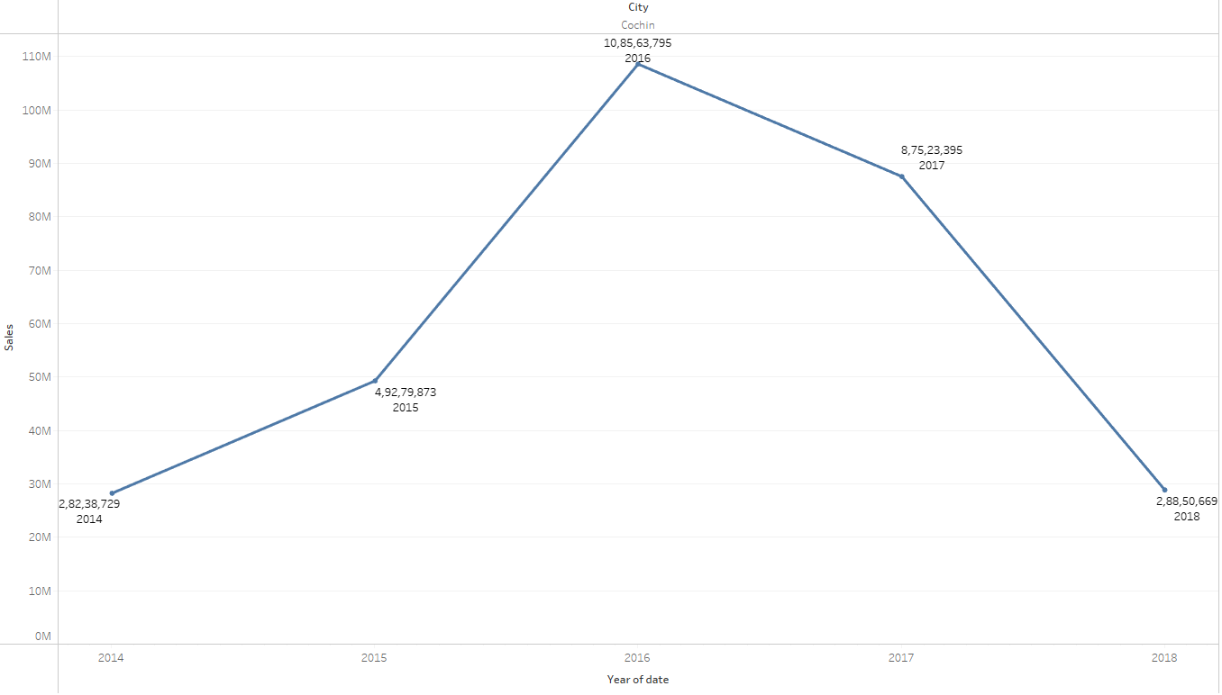 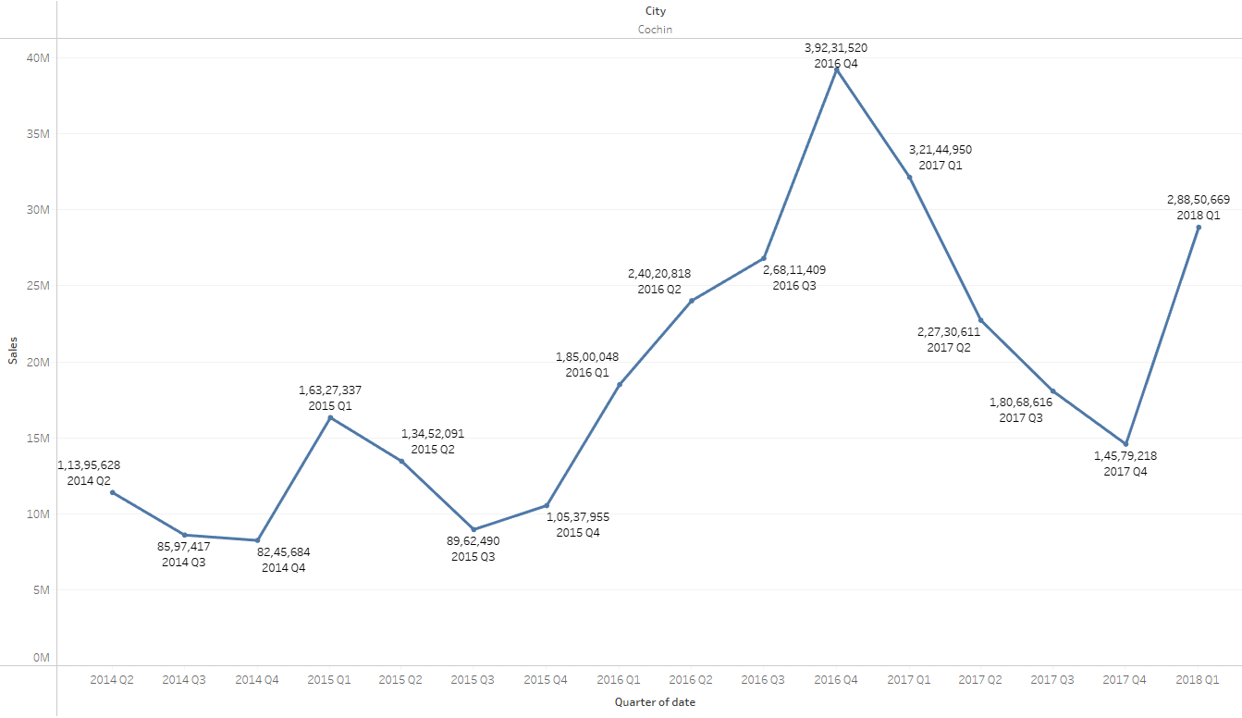 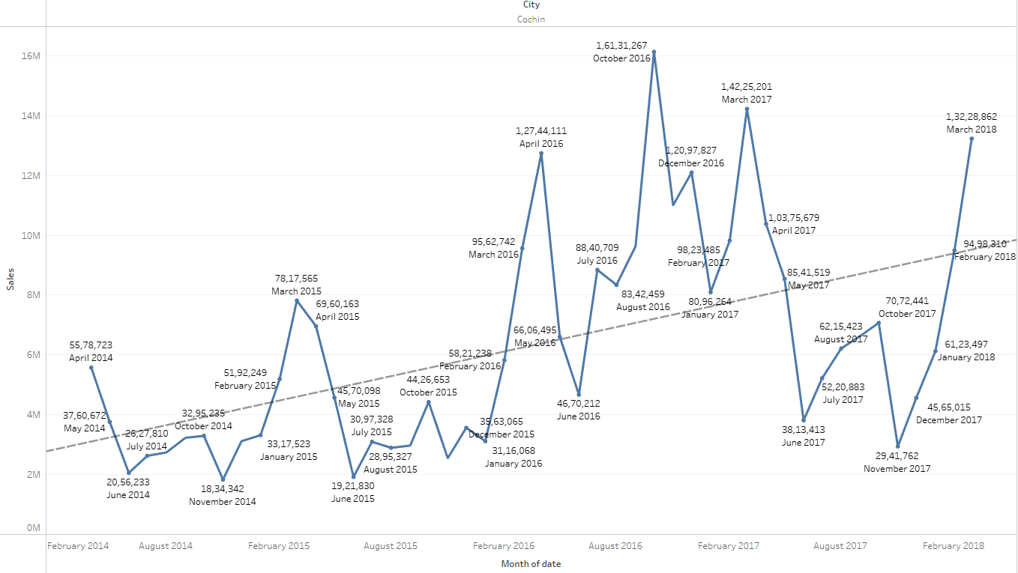

Yearly - Sales in 2014 started with 30M gradually increased till 2016, dip in 2017 and Q1 of 2018

Quarterly – Sales was at peak during Q4 of 2016

Monthly – There was a constant dip during june across all years and no particular pattern of rise or dip in sales. Trend line increases across the years.

### Delhi

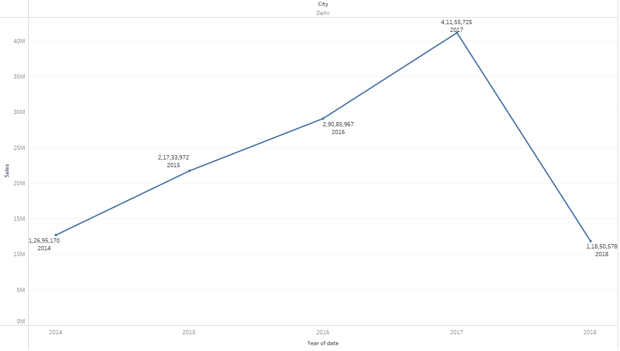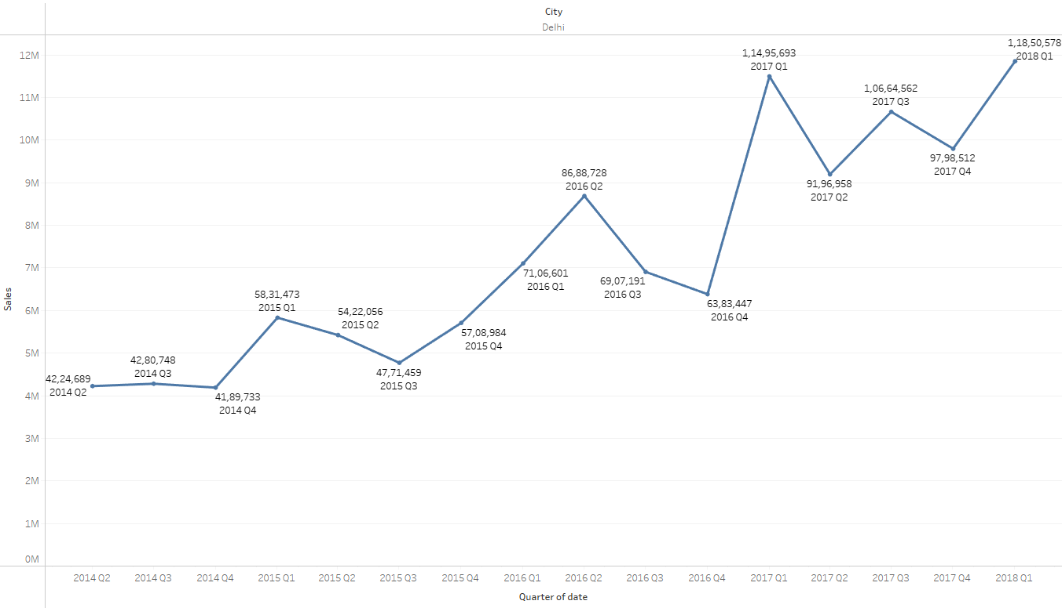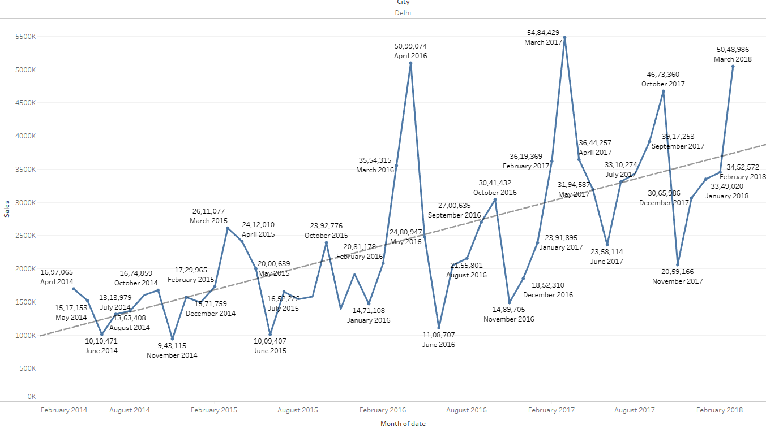

Yearly - Sales in 2014 started with 13M gradually increased till 2017, dip in Q1 of 2018

Quarterly – Sales was at peak during Q1 of 2018, almost all Q4 has dip in sales

Monthly – There was a constant dip during June and November across all years and no particular pattern of rise or dip in sales. Trend line steadily increases across the years. March and April have risen in sales across the years.

### Hyderabad

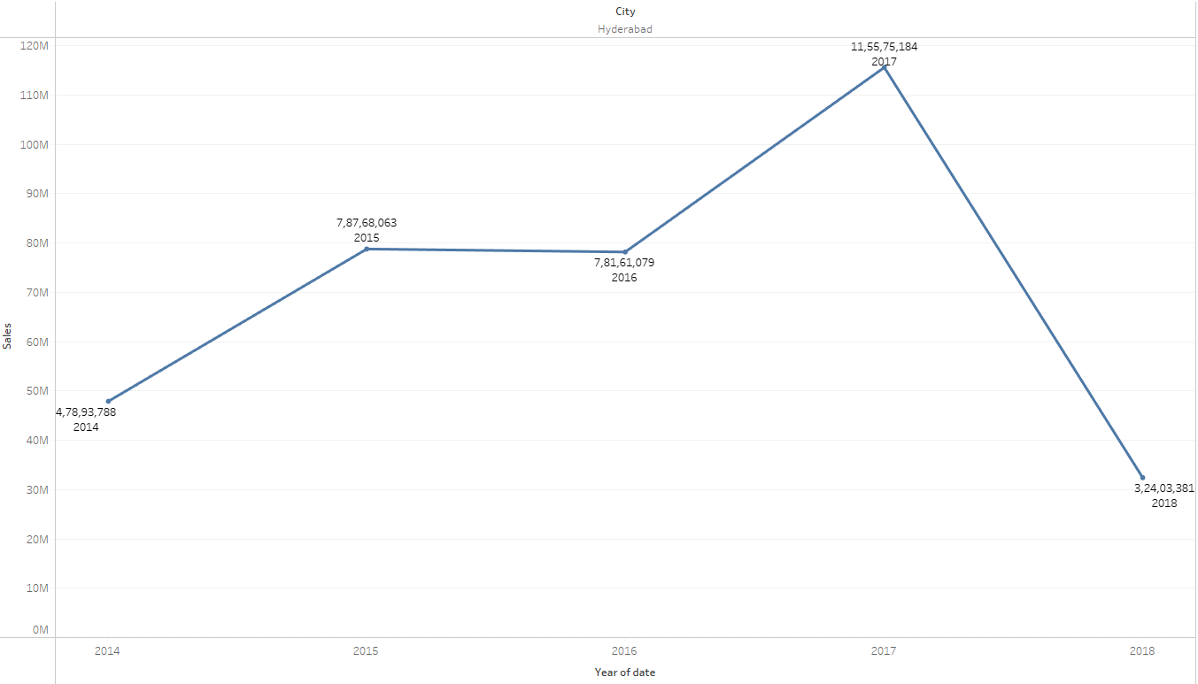 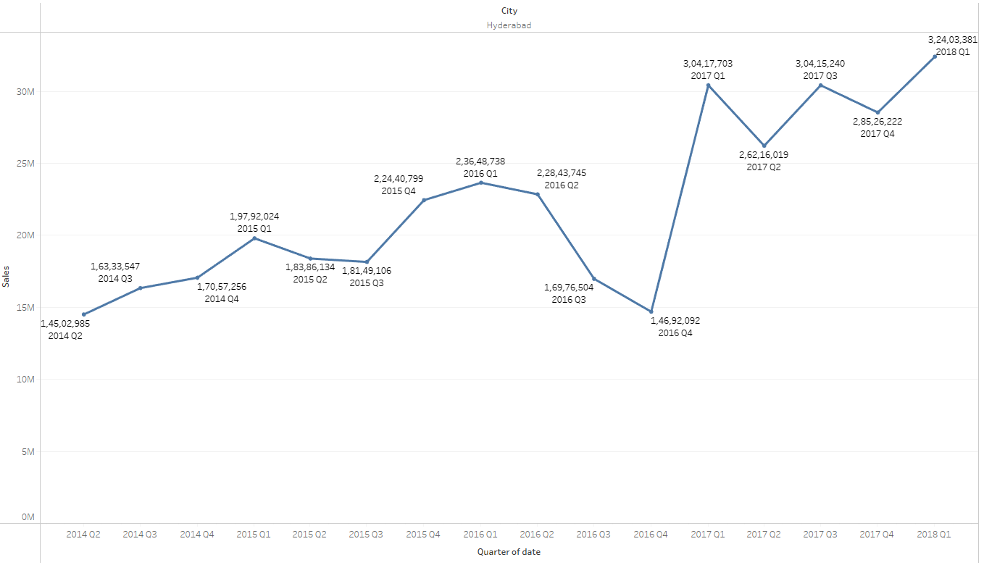 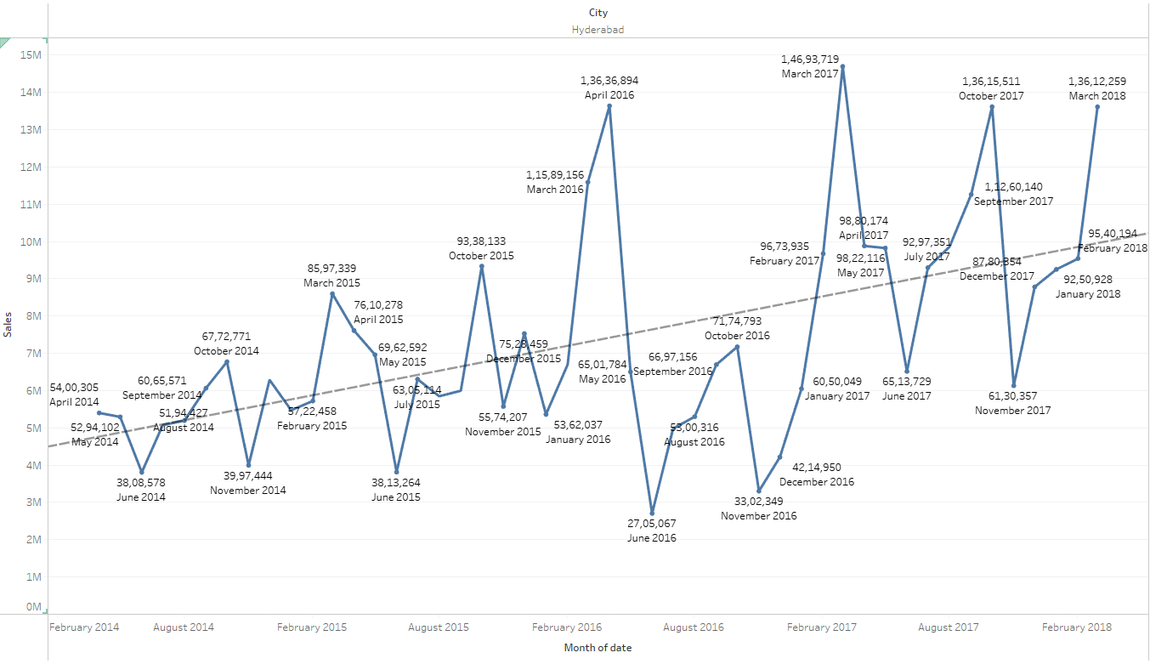

Yearly - Sales in 2014 started with 45M gradually increased till 2015, dip in 2016 and peak at 2017 and again dip in Q1 of 2018

Quarterly – Sales was at peak during Q1 of 2018

Monthly – There was a constant dip during june and november across all years and no particular pattern of rise or dip in sales. Trend line increases acroos the years.

### Kolkata

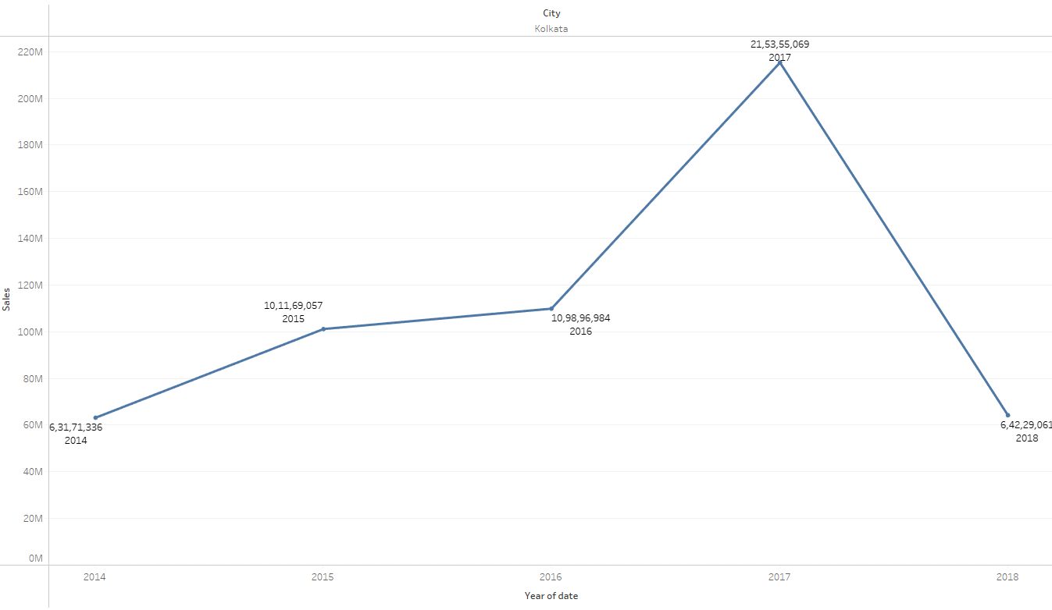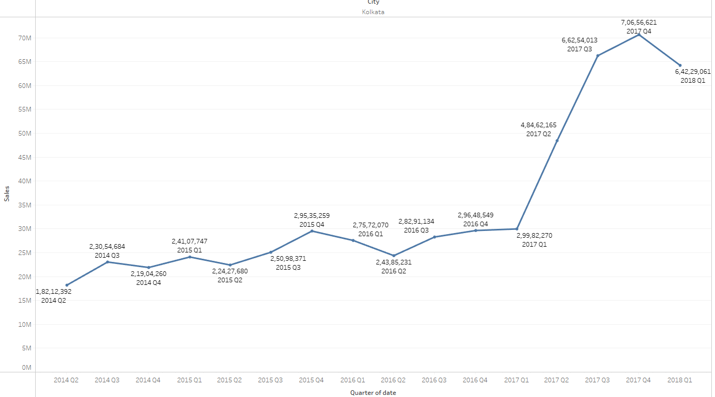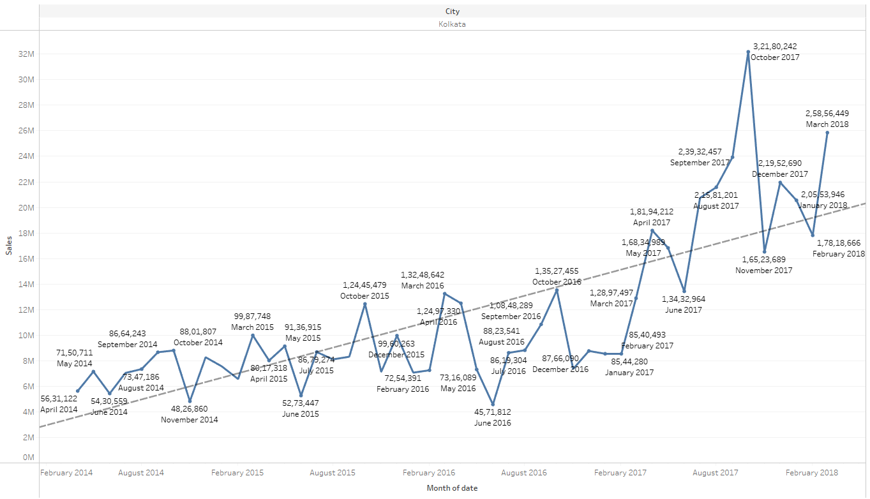

Yearly - Sales in 2014 started with 60M increased till 2017, dip in Q1 of 2018

Quarterly – Sales was at peak during Q4 of 2017

Monthly – There was a constant dip during june and november across all years and no particular pattern of rise or dip in sales. Trend line increases across the years.

### Mumbai

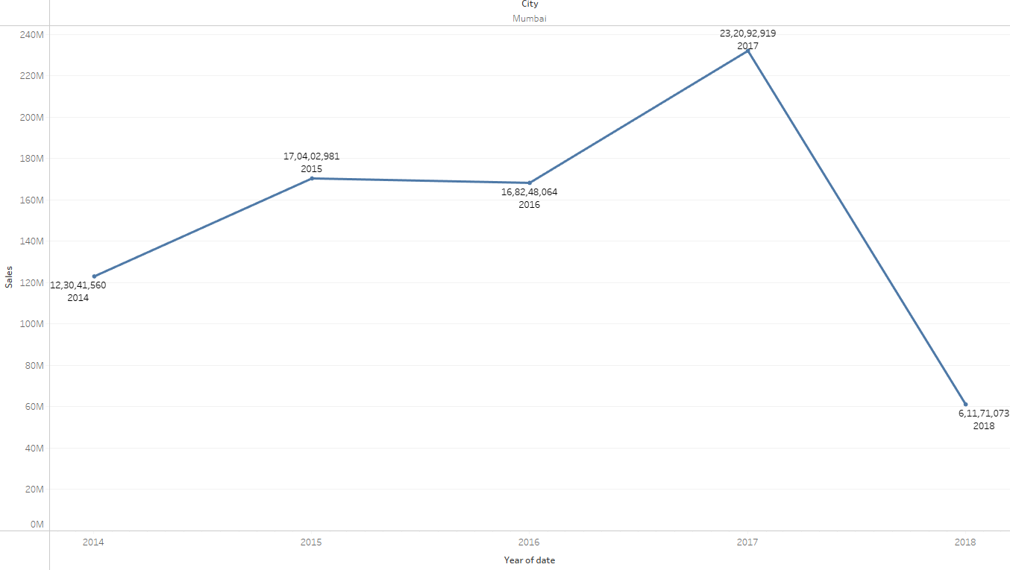 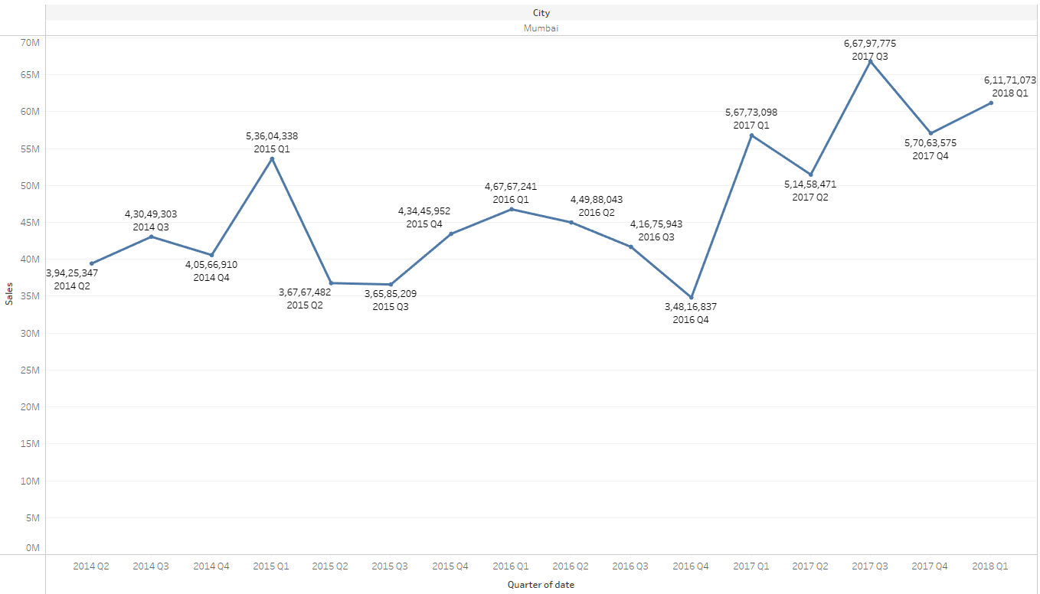 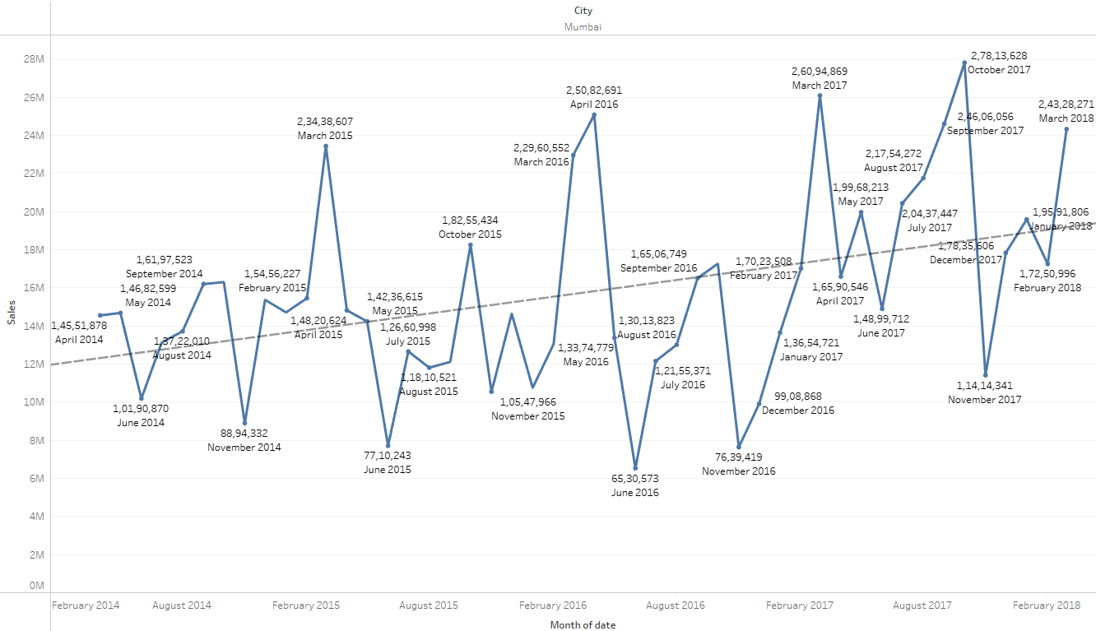

Yearly - Sales in 2014 started with 120M gradually increased till 2015, slight dip in 2016 and peak at 2017and again dip in sales during Q1 of 2018

Quarterly – Sales was at peak during Q3 of 2017

Monthly – There was a constant dip during june and november across all years and no particular pattern of rise or dip in sales. Trend line increases acroos the years.

### Patna

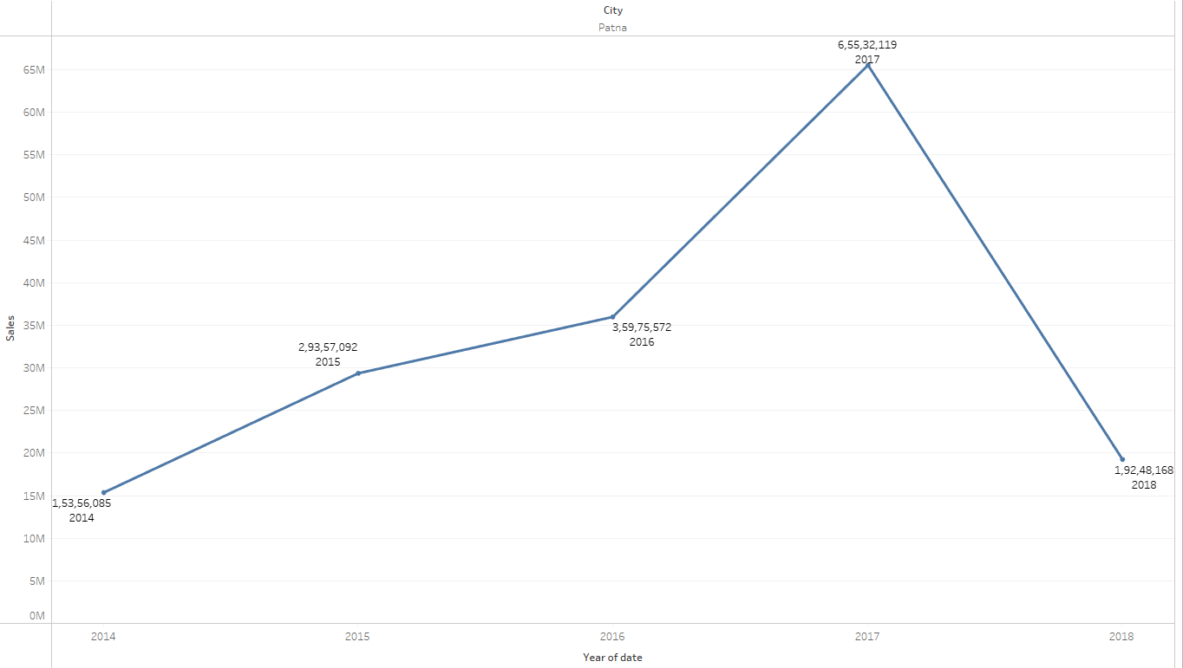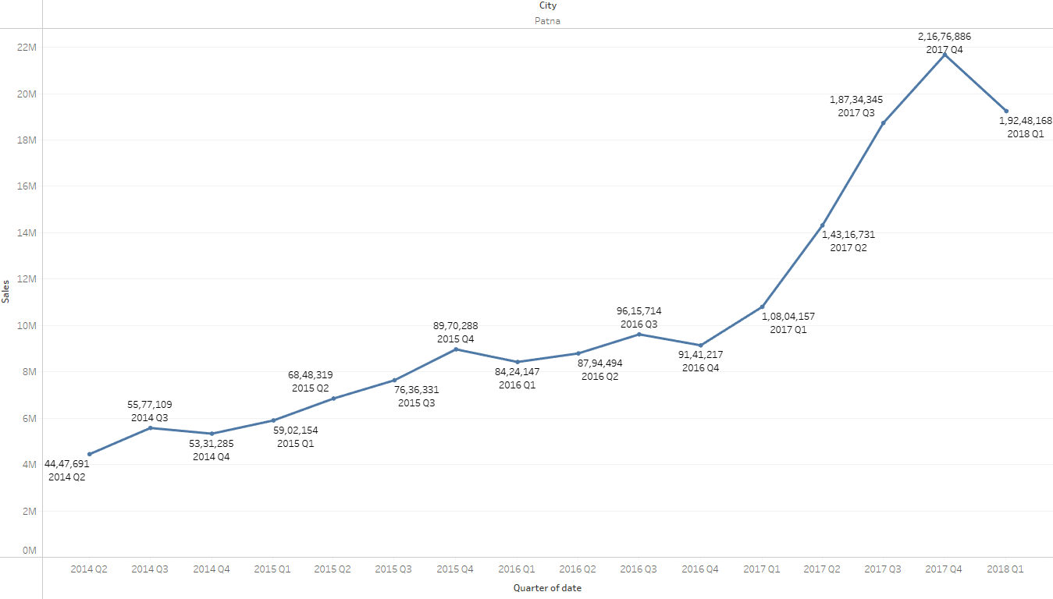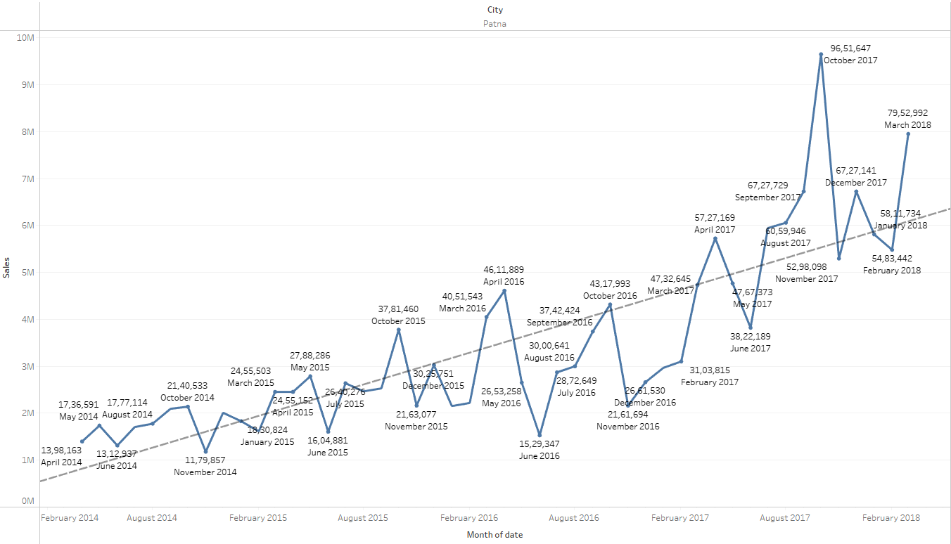

Yearly - Sales in 2014 started with 15M gradually increased till 2017, dip in Q1 of 2018

Quarterly – Sales was at peak during Q4 of 2017

Monthly – There was a constant dip during june and november across all years and no particular pattern of rise or dip in sales. Trend line steadily increases across the years.

### Pune

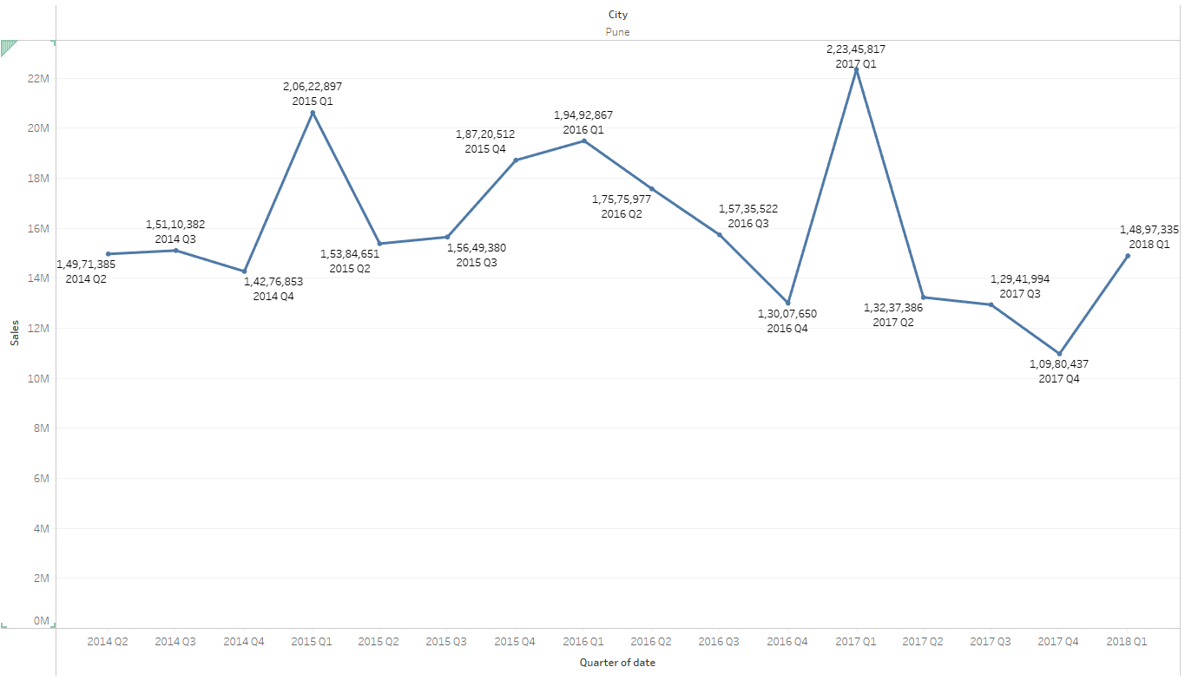 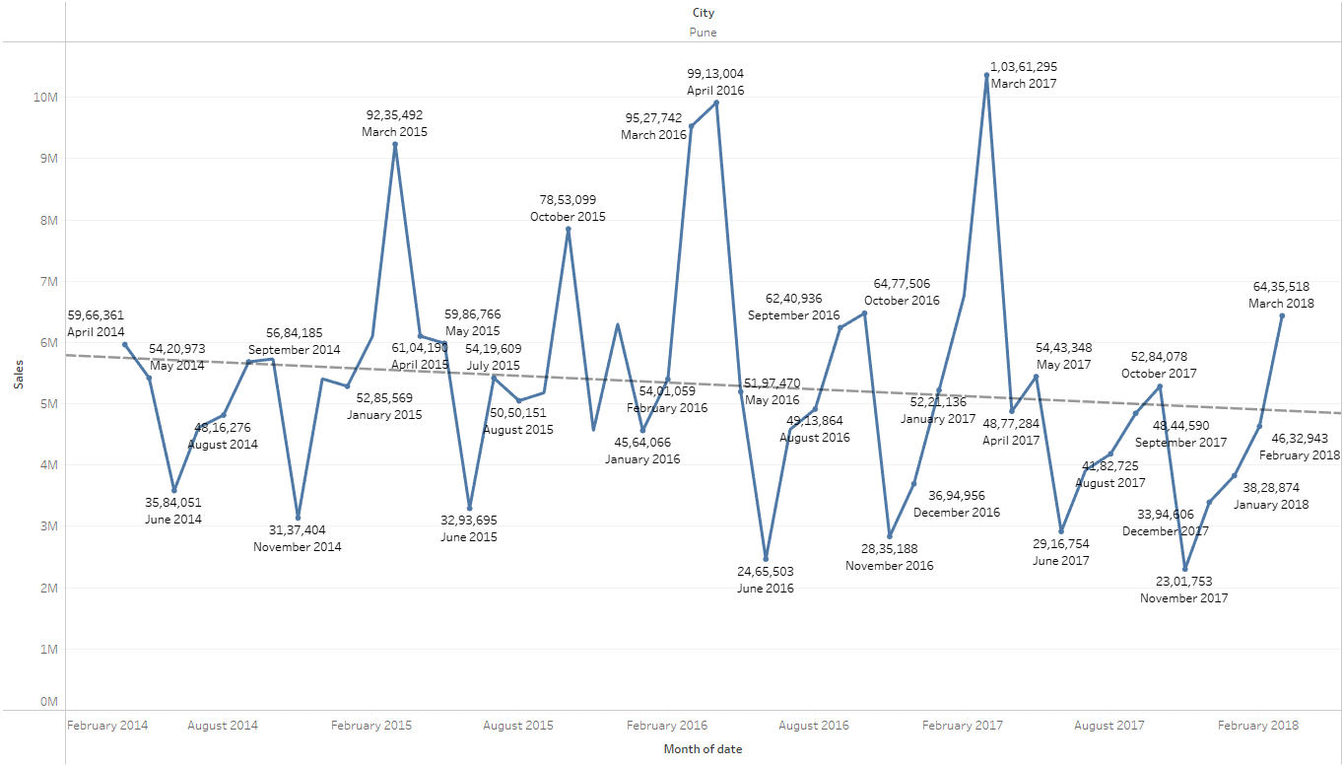

Yearly - Sales in 2014 started with 43M gradually increased till 2015, gradually decreased from 2016 to 2018

Quarterly – Sales was at peak during Q1 of 2017

Monthly – There was a constant dip during June and November across all years and no particular pattern of rise or dip in sales. Trend line decreases across the years.

## Date and city and sales and product

### Cooler vs Cities vs Date

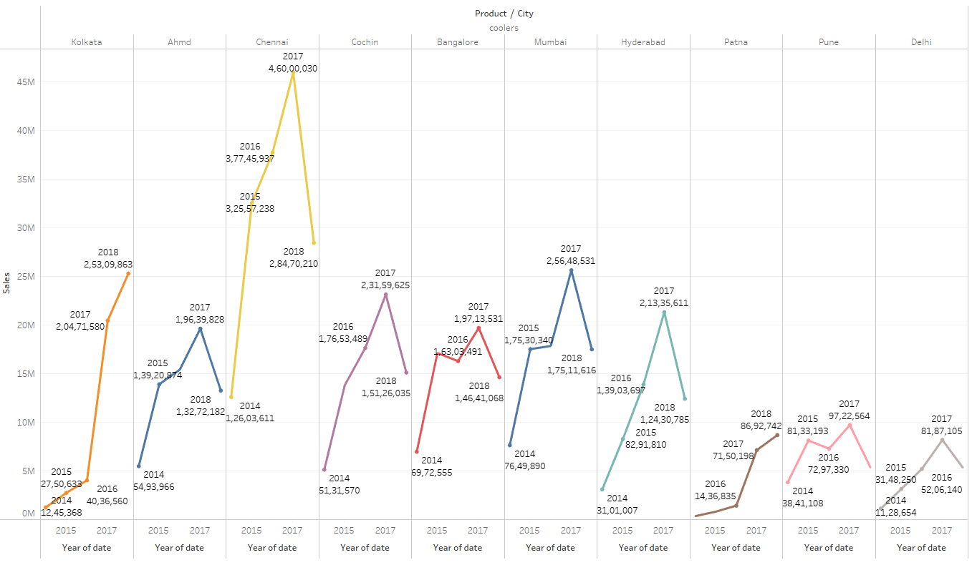 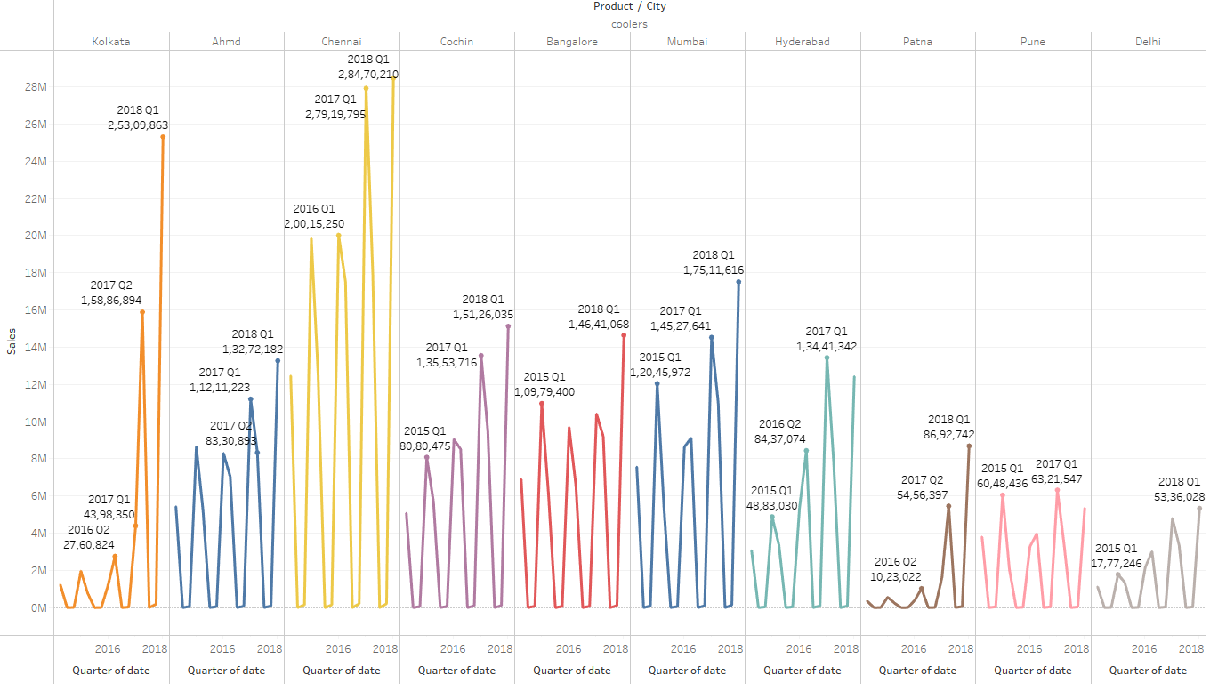 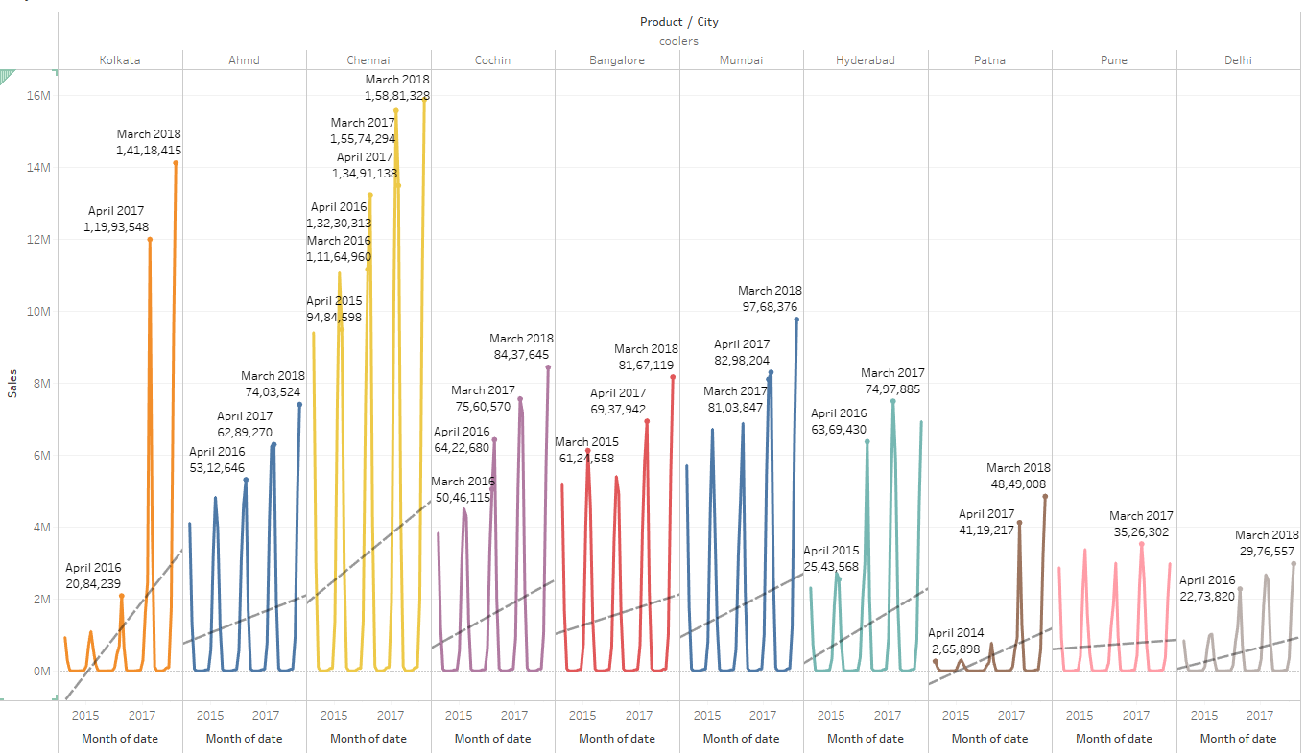

Yearly – Kolkata, Chennai, Patna, Delhi and Cochin shows an increase in sales steadily from 2014 to 2017 and dip in Q1 of 2018. Ahmedabad, Bangalore, Mumbai, Pune increases in sales from 2014, but there is a sudden decreases in sales in between and gradual increase till 2017.

Quarterly - There is a pattern of decrease in sales during Q3 and Q4 of Cooler across all cities

Monthly – July to December there is decrease in sales and march has the highest sales across all cities. There is increase in trend line in all cities except in Pune

### Dry Iron vs Cities vs Date

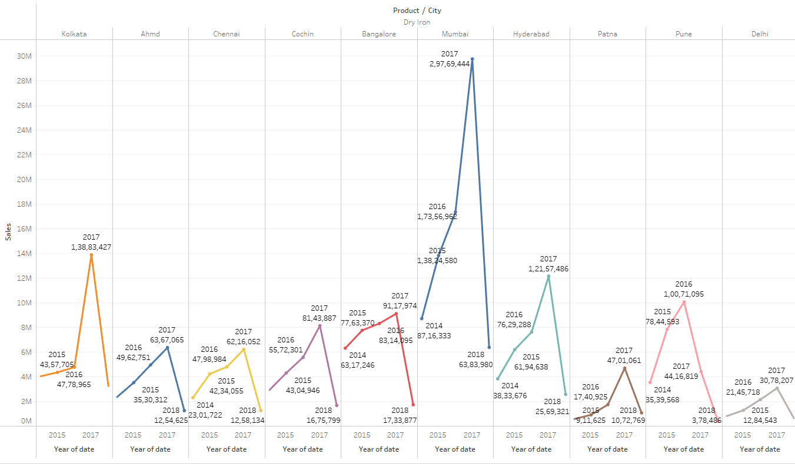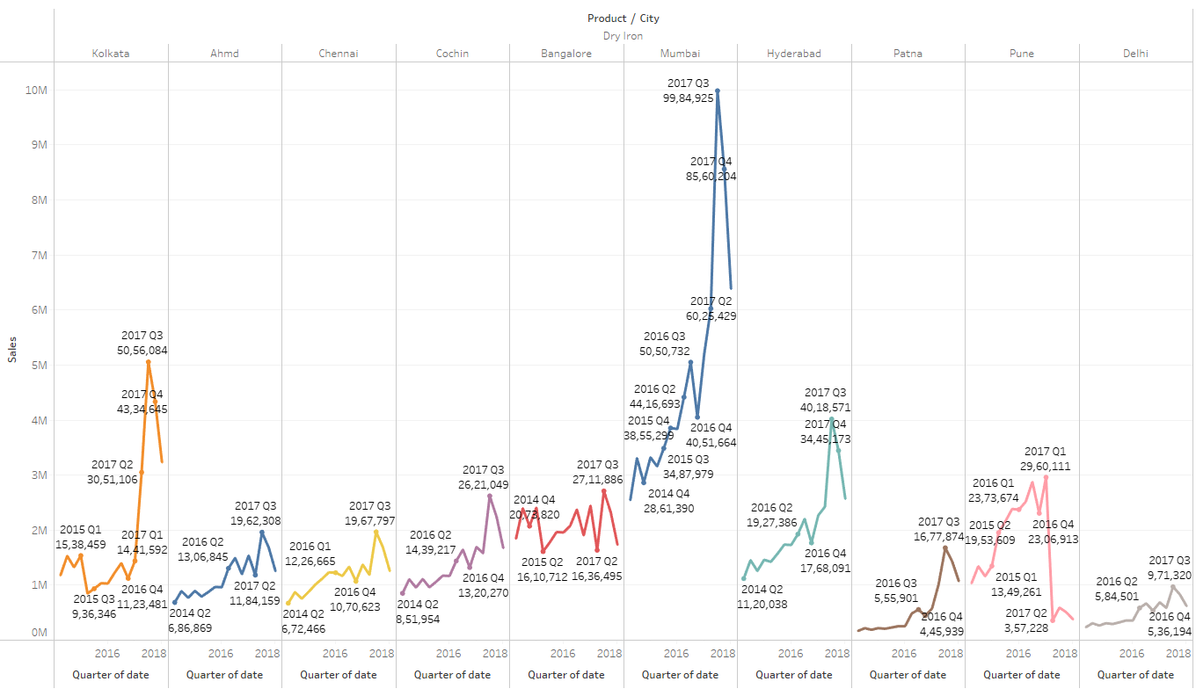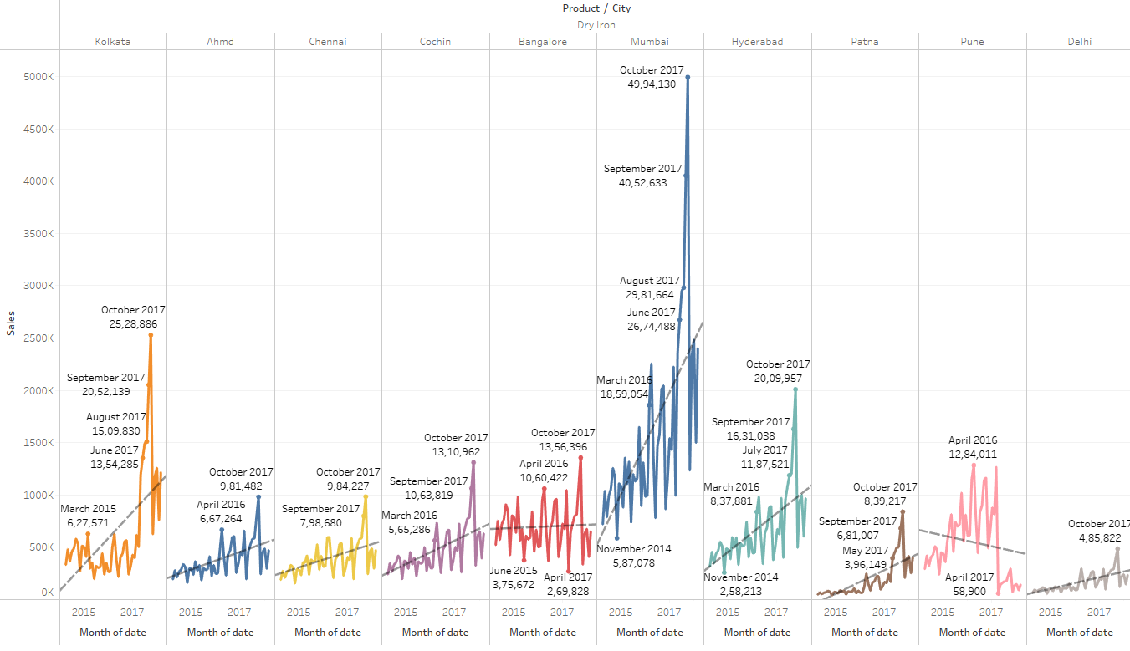

Yearly – All cities shows an increase in sales steadily from 2014 to 2017 and dip in Q1 of 2018. Mumbai shows promising sales than other cities

Quarterly - No pattern of increase or decrease in sales. But sales gradually increases with slight dip in certain months

Monthly –October has the highest sales across all cities. There is increase in trend line in all cities except in Pune

### Food Processor vs Cities vs Date

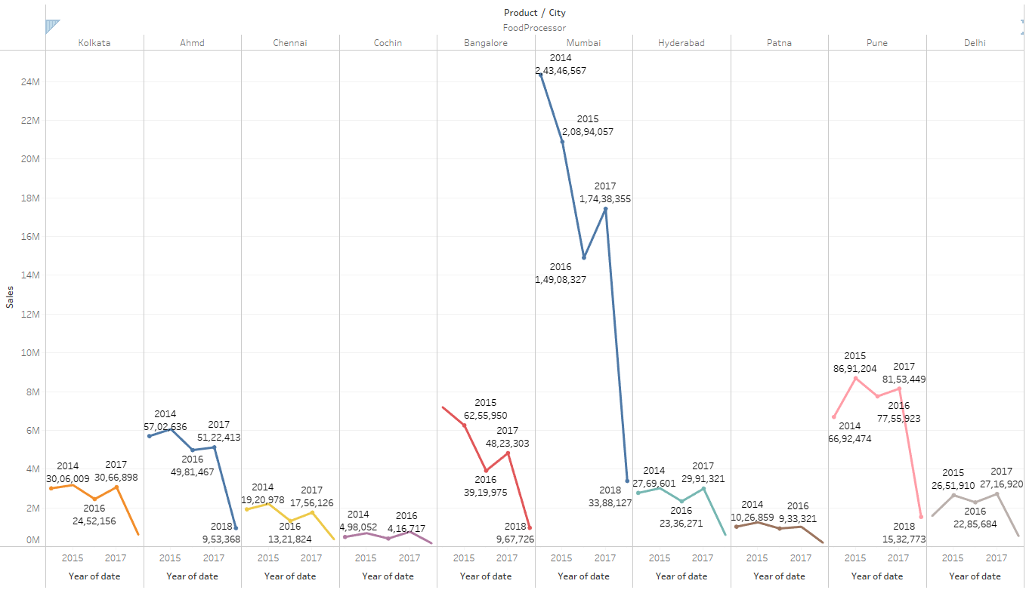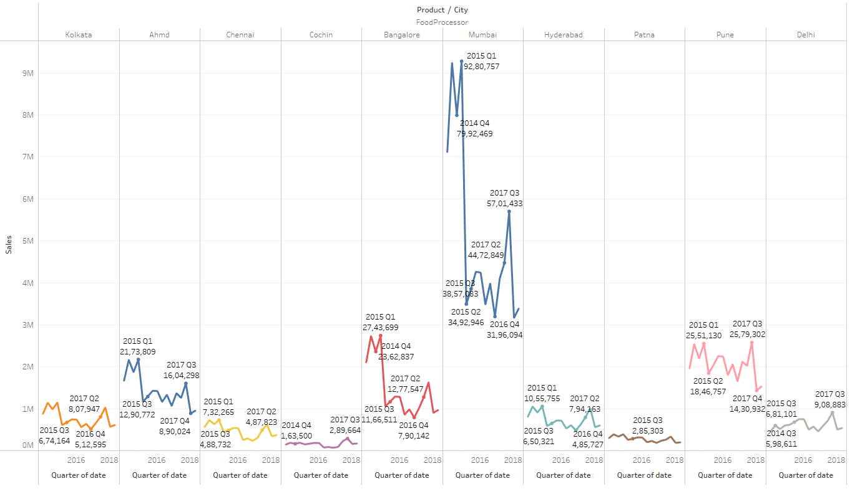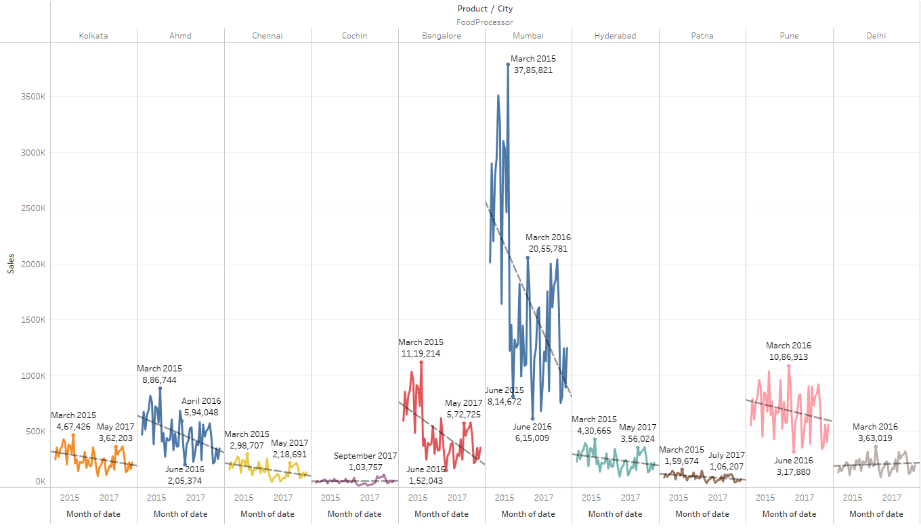

Yearly – All cities shows decrease in sales steadily from 2014 to 2017 and slight increase in sales in 2017, 2015 of 2014. Mumbai had highest sales during 2014 than other cities

Quarterly - No pattern of increase or decrease in sales. But sales gradually decreases

Monthly –Mostly march has the highest sales across all cities except Cochin. There is decrease in trend line in all cities except Delhi, which has flat trend line

### Gas Stove vs Cities vs Date

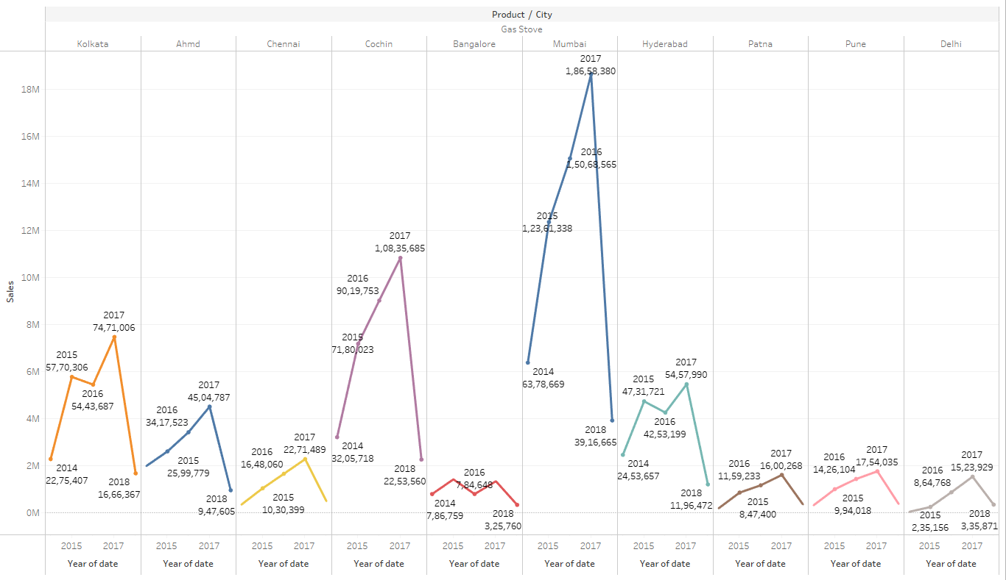 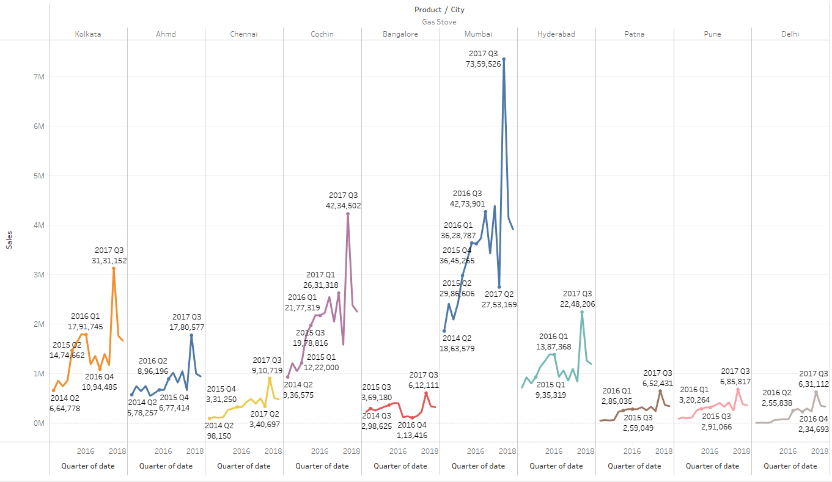 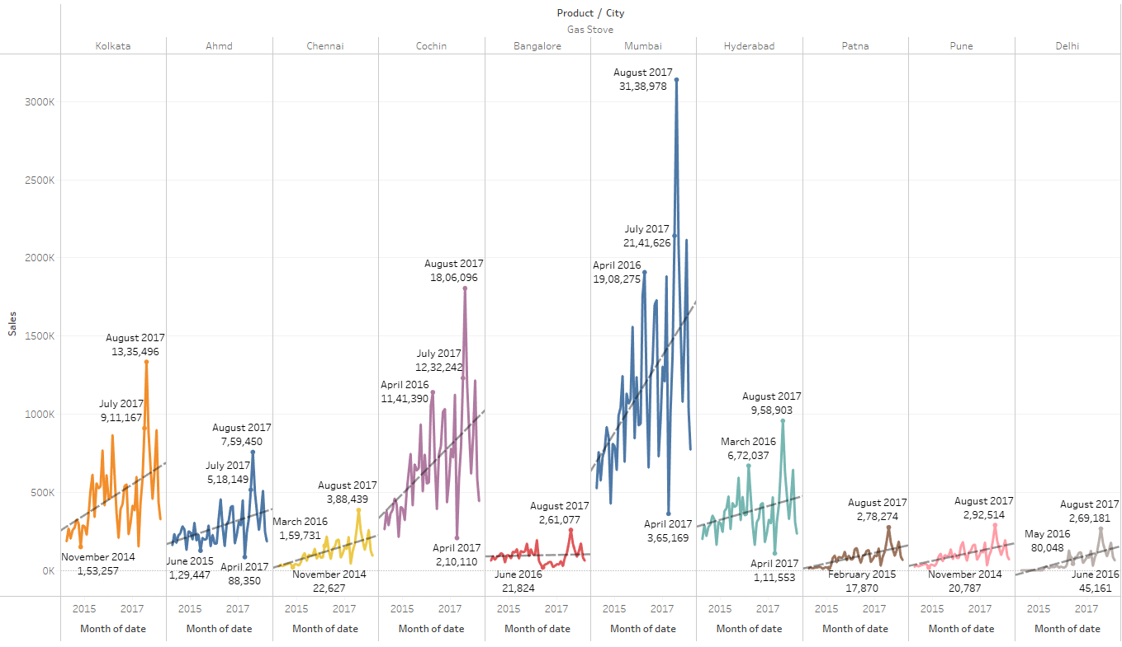

Yearly – Ahmedabad, Chennai, Cochin, Mumbai, Patna, Pune and Delhi shows an increase in sales steadily from 2014 to 2017 and dip in Q1 of 2018. Whereas Kolkata, Bangalore, Hyderabad have dip in sales in between.

Quarterly - Q3 has the highest number of sales across all cities. But sales gradually increases with slight dip in certain months

Monthly –August has the highest sales across all cities. There is increase in trend line in all cities except in Bangalore , which has a flat line.

### Induction Cookers vs Cities vs Date

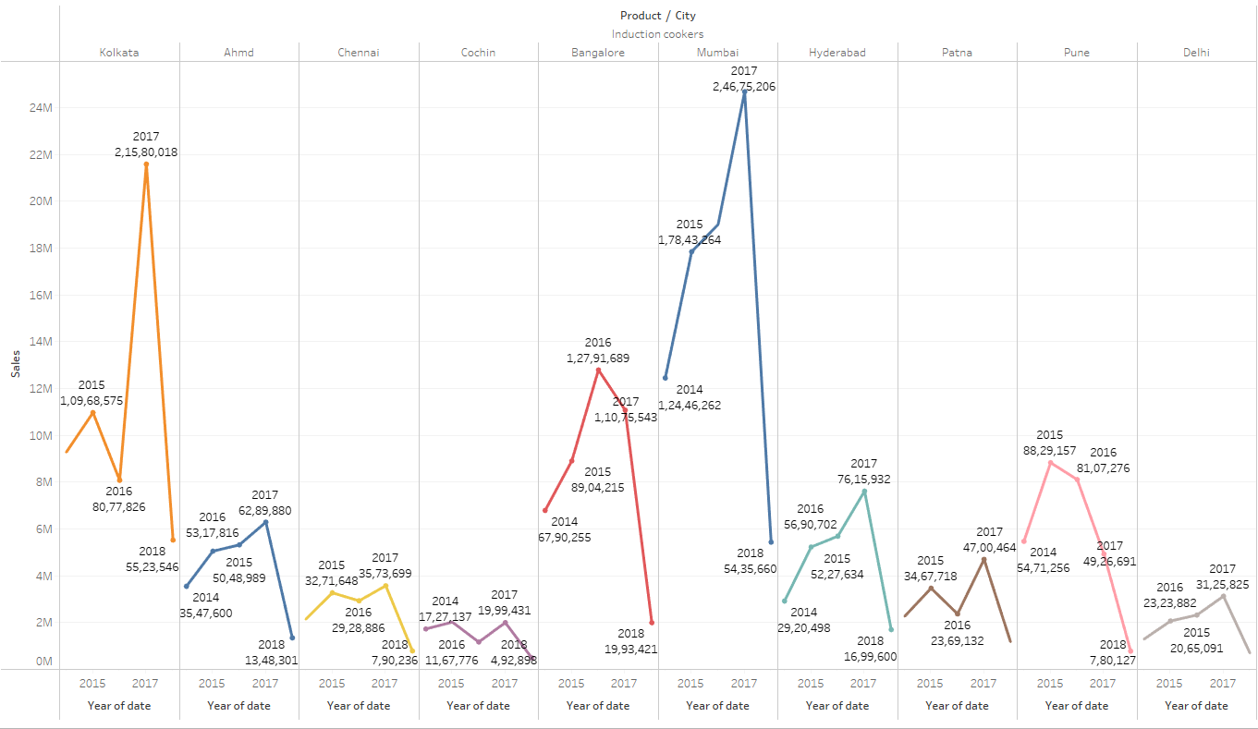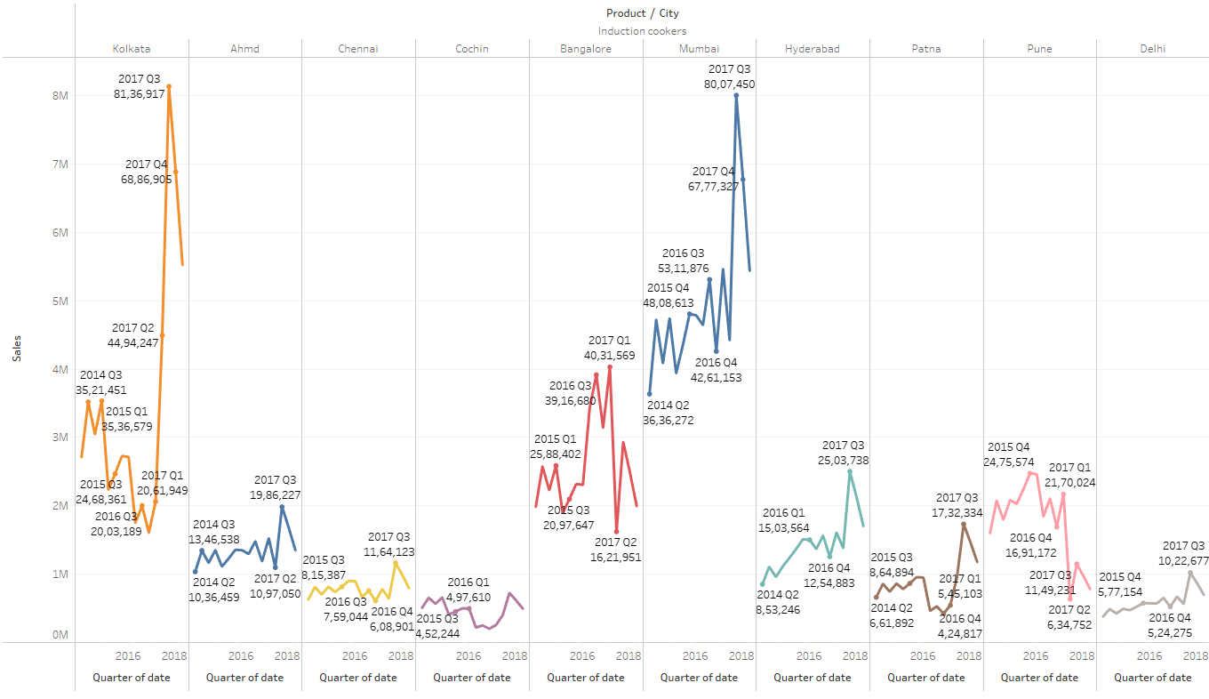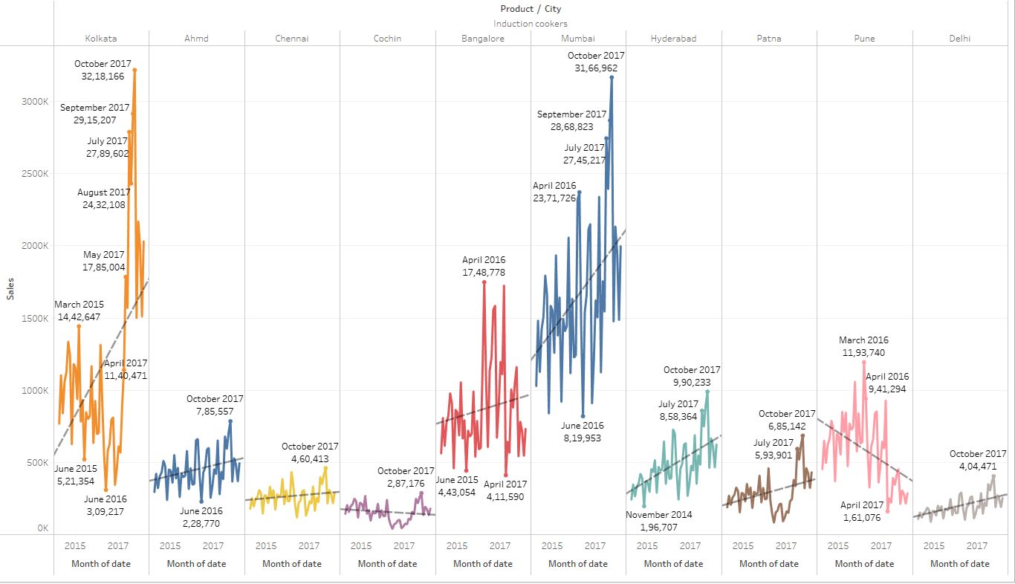

Yearly – Mumbai shows promising sales than other cities. Sales of induction cookers is not consistent in all cities and it varies across years

Quarterly - No pattern of increase or decrease in sales. But sales gradually increases with slight dip in certain months except Pune, where sales decreases from 2017 Q1

Monthly –October has the highest sales across all cities except Pune and Bangalore. There is increase in trend line in all cities except in Pune

### Mixers vs Cities vs Date

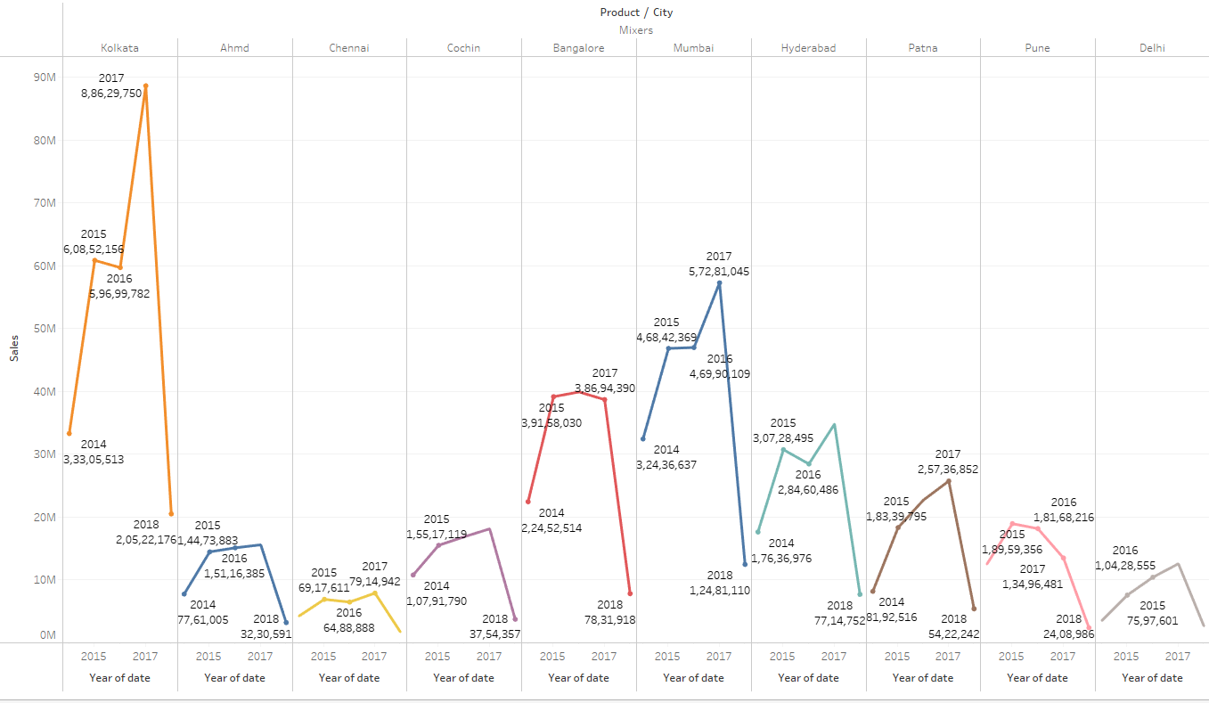 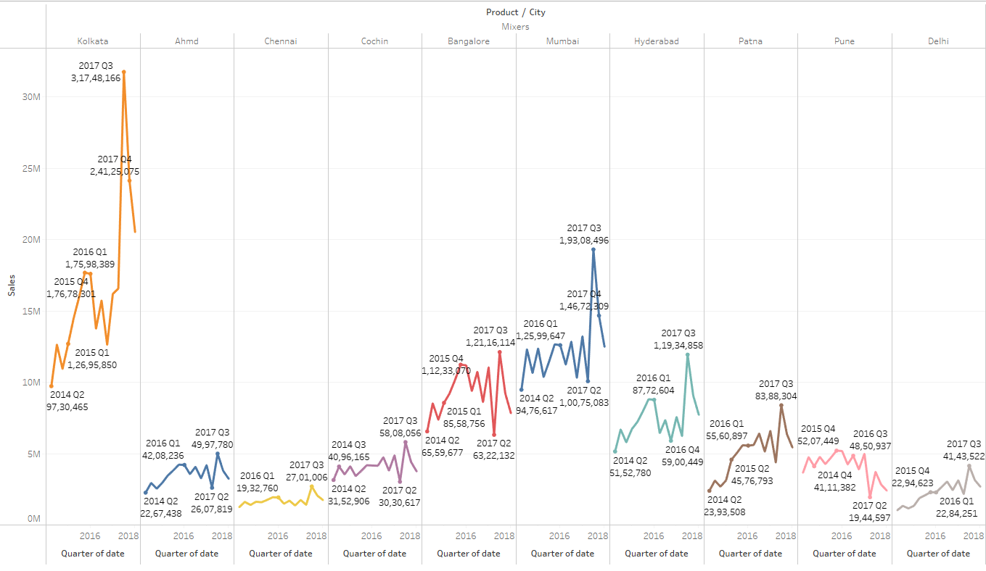 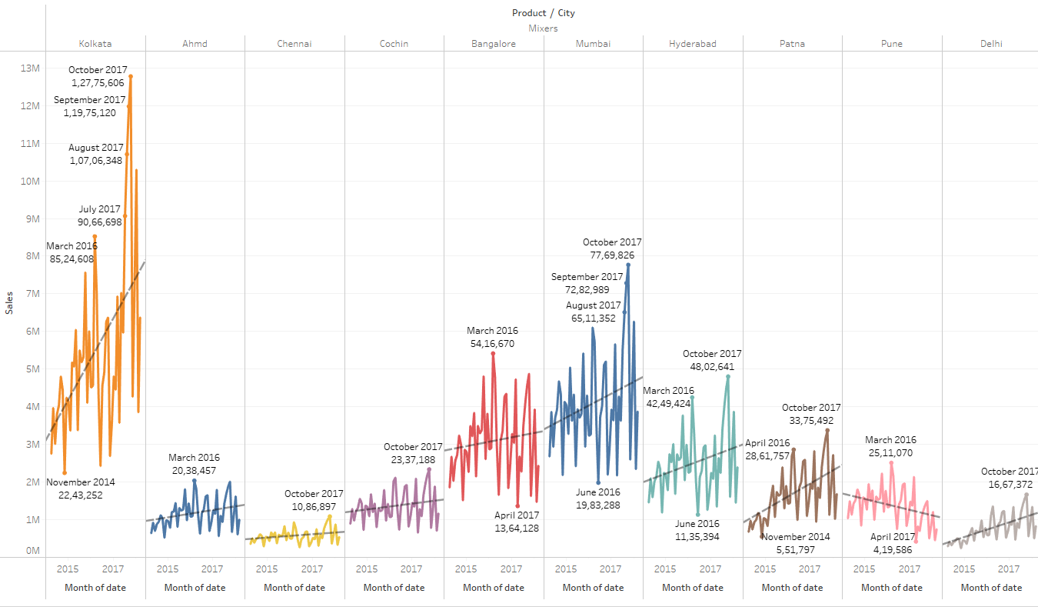

Yearly – Kolkata shows promising sales than other cities. Sales of Mixers is not consistent in all cities and it varies across all years.

Quarterly - No pattern of increase or decrease in sales. But sales gradually increases with slight dip in certain months except pune

Monthly –October has the highest sales across all cities except Pune and bangalore. There is increase in trend line in all cities except in Pune

### Oven toaster grill vs Cities vs Date

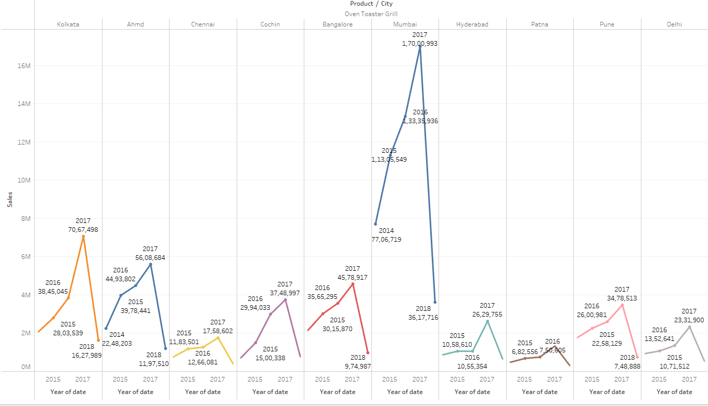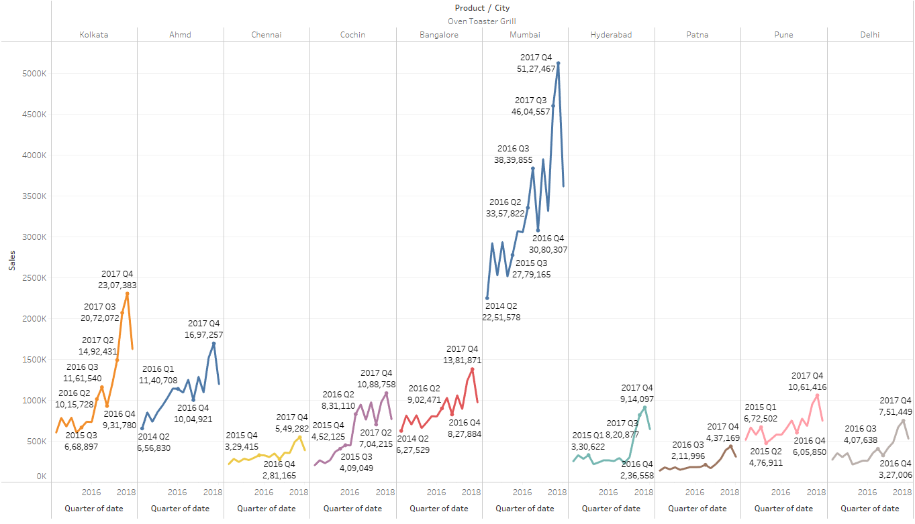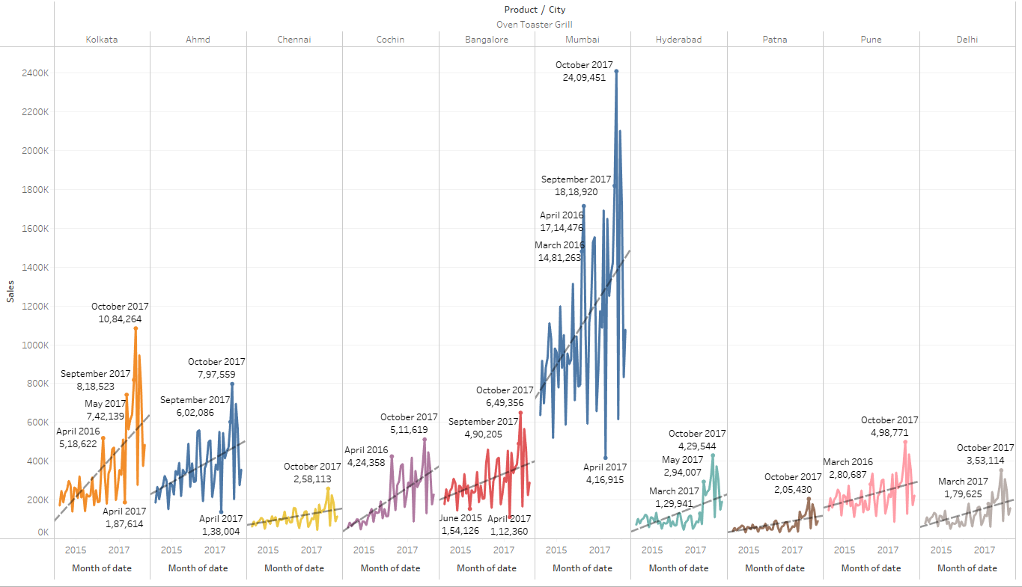

Yearly – Mumbai shows promising sales than other cities. Sales of Oven Toasters gradually increases across years.

Quarterly - No pattern of increase or decrease in sales. But sales gradually increases with slight dip in certain months

Monthly –October has the highest sales across all cities except Pune and Bangalore. There is increase in trend line in all cities

### SECF vs Cities vs Date

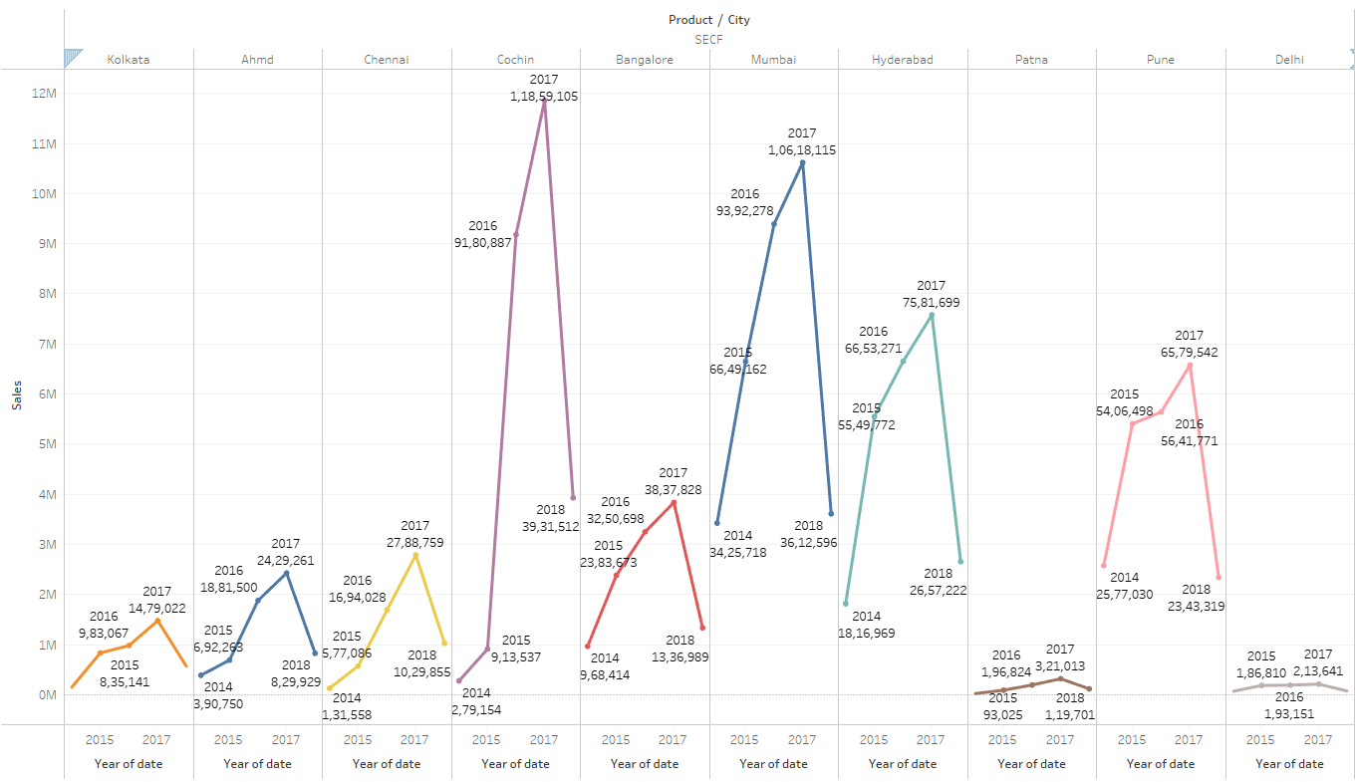 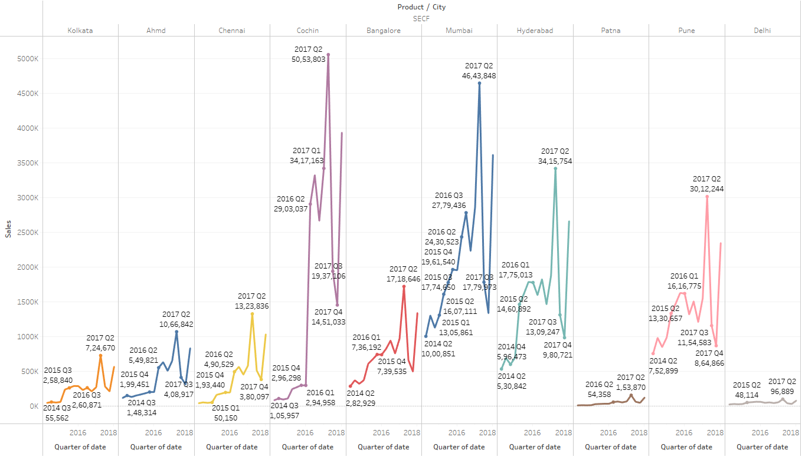 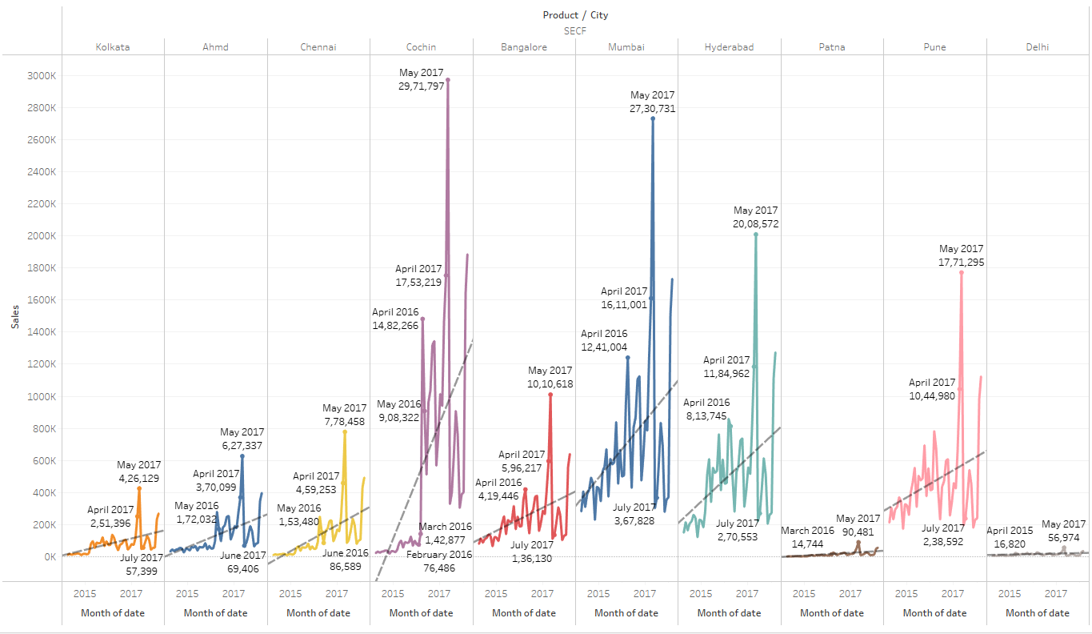

Yearly – Kolkata shows promising sales than other cities. Sales of SECF gradually increases across years.

Quarterly - No pattern of increase or decrease in sales. But sales gradually increases with slight dip in certain months. Q2 shows highest sales across all cities

Monthly –May has the highest sales across all cities. There is increase in trend line in all cities

### Steam Iron vs Cities vs Date

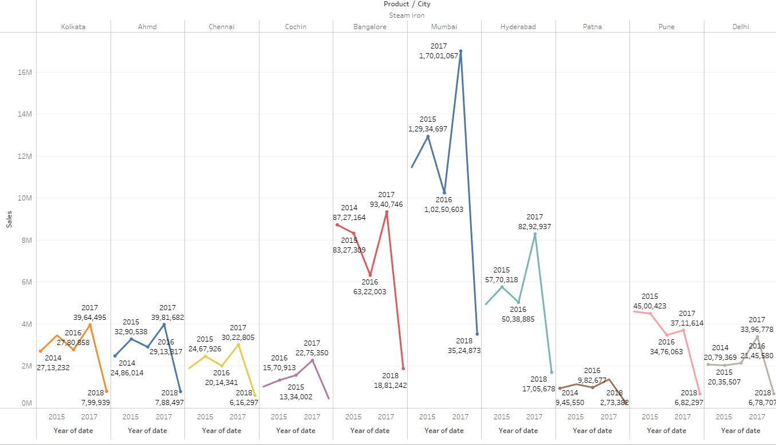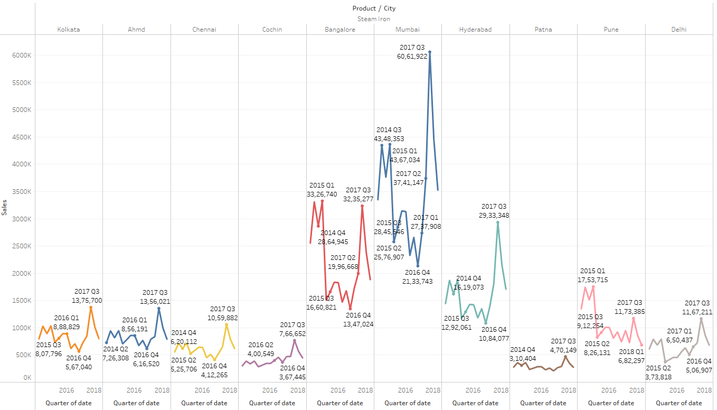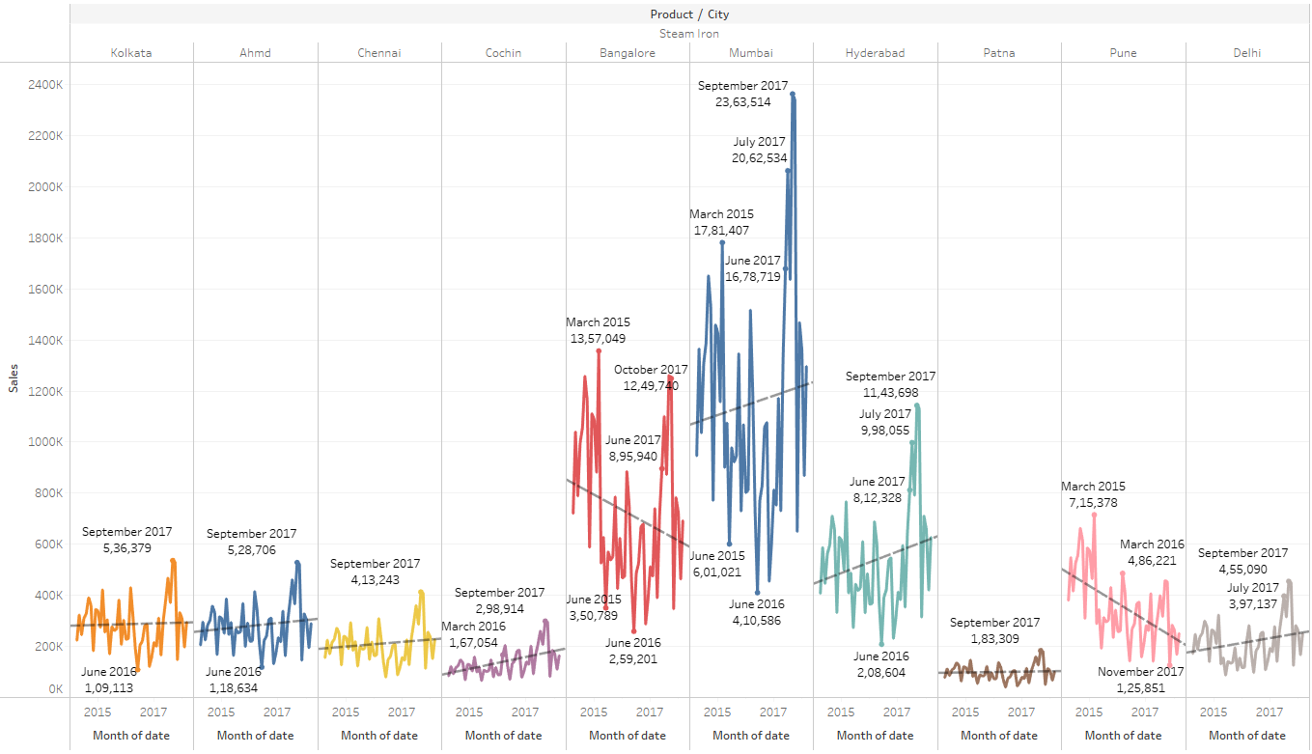

Yearly – Mumbai shows promising sales than other cities. Sales of Steam Iron is not consistent in all cities and it varies across the years

Quarterly - No pattern of increase or decrease in sales. Q3 shows highest sales across all cities

Monthly –September has the highest sales across all cities except Bangalore and pune. There is increase in trend line in Mumbai, Kolkata, Ahmedabad, Chennai ,Hyderabad , Delhi and cochin. Decrease in sales in Pune, Bangalore and flat line in Patna.

### Water Heaters vs Cities Vs Date

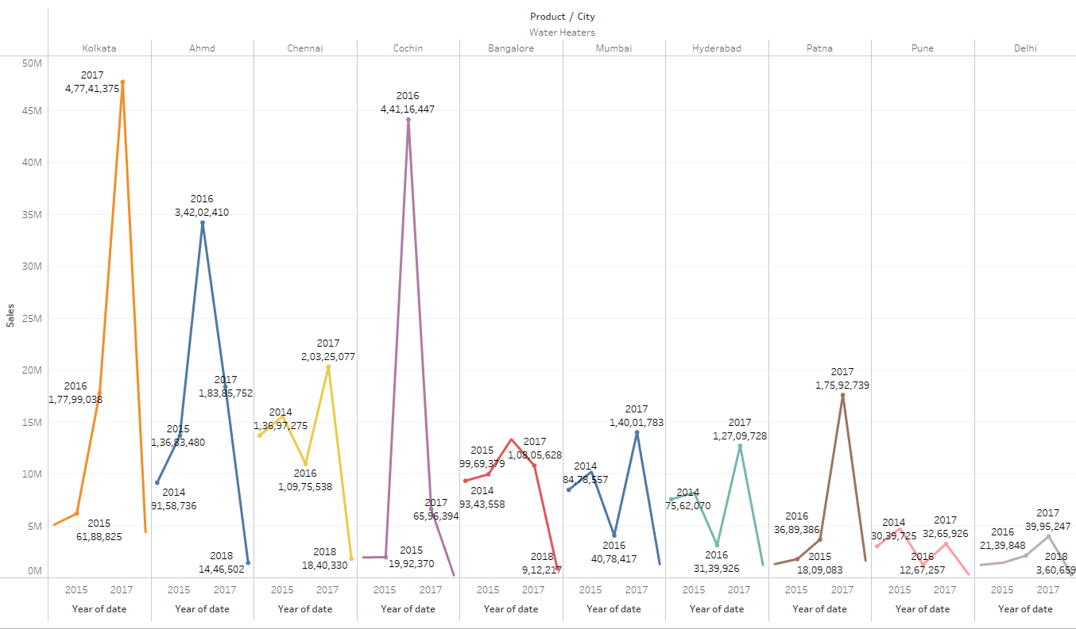 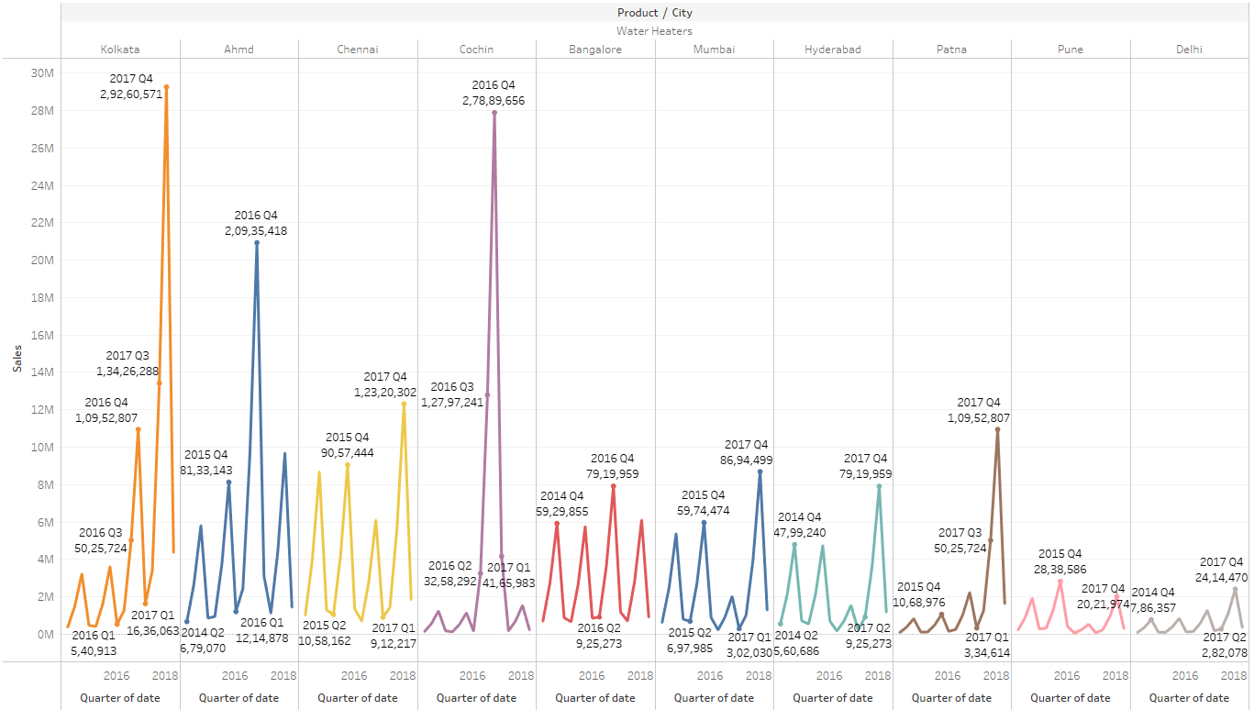 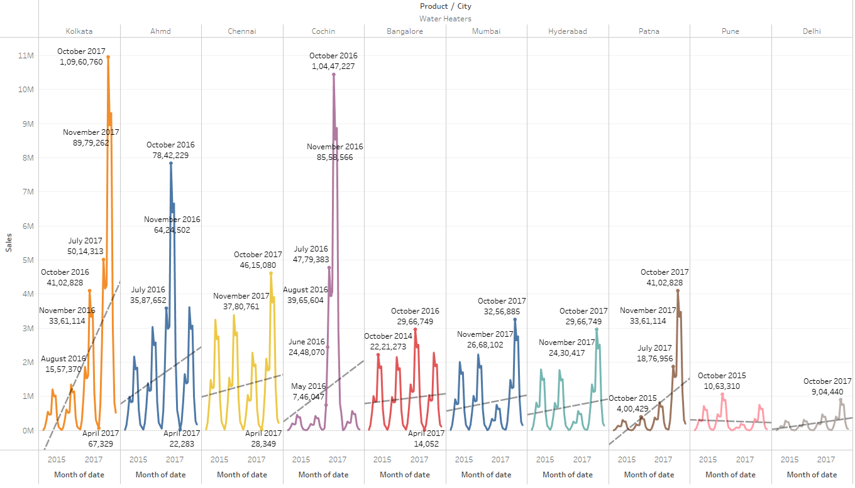

Yearly – Kolkata shows promising sales than other cities. Sales of Water heater is not consistent in all cities and it varies across years

Quarterly - No pattern of increase or decrease in sales. But sales gradually increases with slight dip in certain months except pune. Q4 shows highest sales across all cities

Monthly –October has the highest sales across all cities. There is increase in trend line in all cities except Pune.

## Missing Data and duplicates

There is no Missing data and duplicates in the dataset.

## Outlier treatment

No outlier treatment for sales since dates and sales are continuous over a period of time. Forecasting data will be affected if outliers are treated

# Business Insights

Time series is continuous so there is no Imbalance

No clustering because data has to be split based on distance and similarity. Cannot remove product and city, which are key variables in the data set

From the EDA point of view, For coolers product Chennai holds highest sales and Delhi holds lowest sales. Therefore Q1 and Q2 production should be high and rest of the quarters, production is almost zero in all cities, hence production of products can be increased and off season promotion offers can be implemented such as discounted rates or free warranty extension during off seasons sales purposes.

For Dry Iron Highest is recorded in Mumbai and lowest in Delhi. Production should be high in Mumbai and less in Delhi. Q3 records high sales, Q2 and Q4 records comparatively low sales, hence, promotions such as offering iron stand free along with the product can promote sales during low sales. Pune on the other hand declines sales, so additional promotional or discounts can be advertised to attract customers.

For Food processor Mumbai has highest sales and Patna records lowest sales. Q1 and Q3 in almost all cities records good sales. Cochin records almost flat line in sales, hence additional advertisement have to be followed in the city for awareness of the product and its utilities. In other quarters, company can give additional warranty free for promotional purpose.

For Gas Stove Again Mumbai records highest sales and Bangalore , Delhi are almost low in sales. Q3 records highest sales in almost all cities. Hence in Bangalore and Delhi , discounted prices such as 20% flat offer or exchange of old Gas stove, one can buy new gas stove for discounted rates can be offered during low sales period.

For Induction Cookers, Kolkata and Mumbai has the highest sales and Cochin and Delhi has declining sales. Awareness about induction cookers can be advertised in newspapers because this product is not widely used in all cities, hence promotional offers such as exchange of old cookers , one can get discounted Induction cookers can be offered.

For Mixers, Kolkata has highest sales and Chennai has the lowest sales. Q3 has the highest sales in all cities. Extension of motor warranty of mixers can be offered to customers or additional juicer jar can be offered free during low sales time.

For oven Toaster Grill, Mumbai records highest sales, Chennai has the lowest sales. Almost in all cities Q 4 has the highest sales. So cooking recipe books can be offered free along with the toasters and toaster gloves can also be offered along with discounted rates.

For SECF, Cochin records highest sales, and Delhi has lowest sales. Q2 records highest sales in almost all cities. Sales is good in almost all cities. Hence, additional discounted offers can be provided to the customers.

For Steam iron, Mumbai records highest sales and cochin has lowest sales. Q3 has highest sales in almost all cities and Bangalore shows a declining trend. Hence, ironing table can be promoted with discounted rate as a combo offer to the customer during low sales.

For water heaters, Kolkata and cochin has highest sales and Pune has lowest sales and there is a trend , where Q1 and Q2 has lowest sales. Hence , Warranty extension for water heaters and additional offers can be promoted.

Kolkata, Mumbai are high in population, hence high sales can be seen in these sates. Whereas, Delhi, pune and Patna sales will be low due to less population on the whole.